
(Make your own copy by clicking the File menu, and then Make a copy)

Lesson 3: Wayback Machine
Name: | ................................................................................................................ | Class: | .............

Time Travel Web Page Activity Instructions:
- Open a new tab
- Go to web.archive.org OR this alternative

- Type your school’s web address in the search box
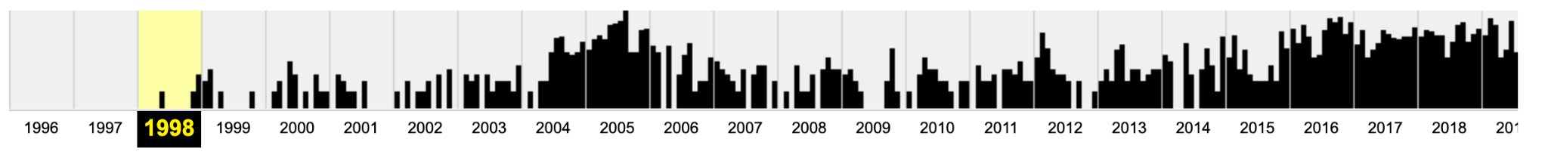
You will see a timeline of web page ‘captures’ for your chosen website. In this example, the first record of the website in wayback in 1998!

- Click on the earliest entry
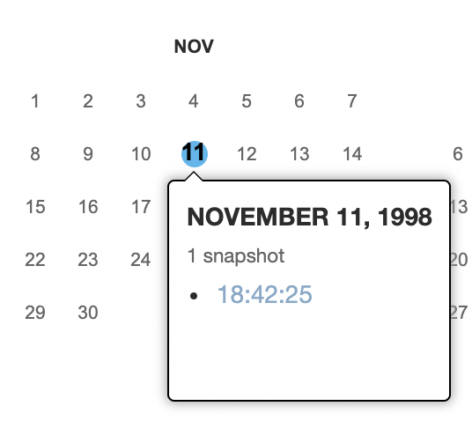 | - On the timeline, click on the earliest year the webpage has a history for  - On the calendar, ‘mouse over’ the dates that have been shaded - this example has November 11, 1998 with a blue circle  - Click on the ‘snapshot’ (18:42:25)  - You should be able to see the first webpage  Note: sometimes error messages may come up. If this happens, choose the next ‘earliest’ date and try again.

- Take a screenshot of the ‘Oldest website record’ and insert the image into the table below
- Fast Forward to current day (click your mouse on the timeline for 2022)
- Take a screenshot of ‘Website today’ and insert the image into the table below

Example: | Oldest website record | Website today
Nintendo  Website:  https://www.nintendo.com.au/  #WOW - checkout the difference! | 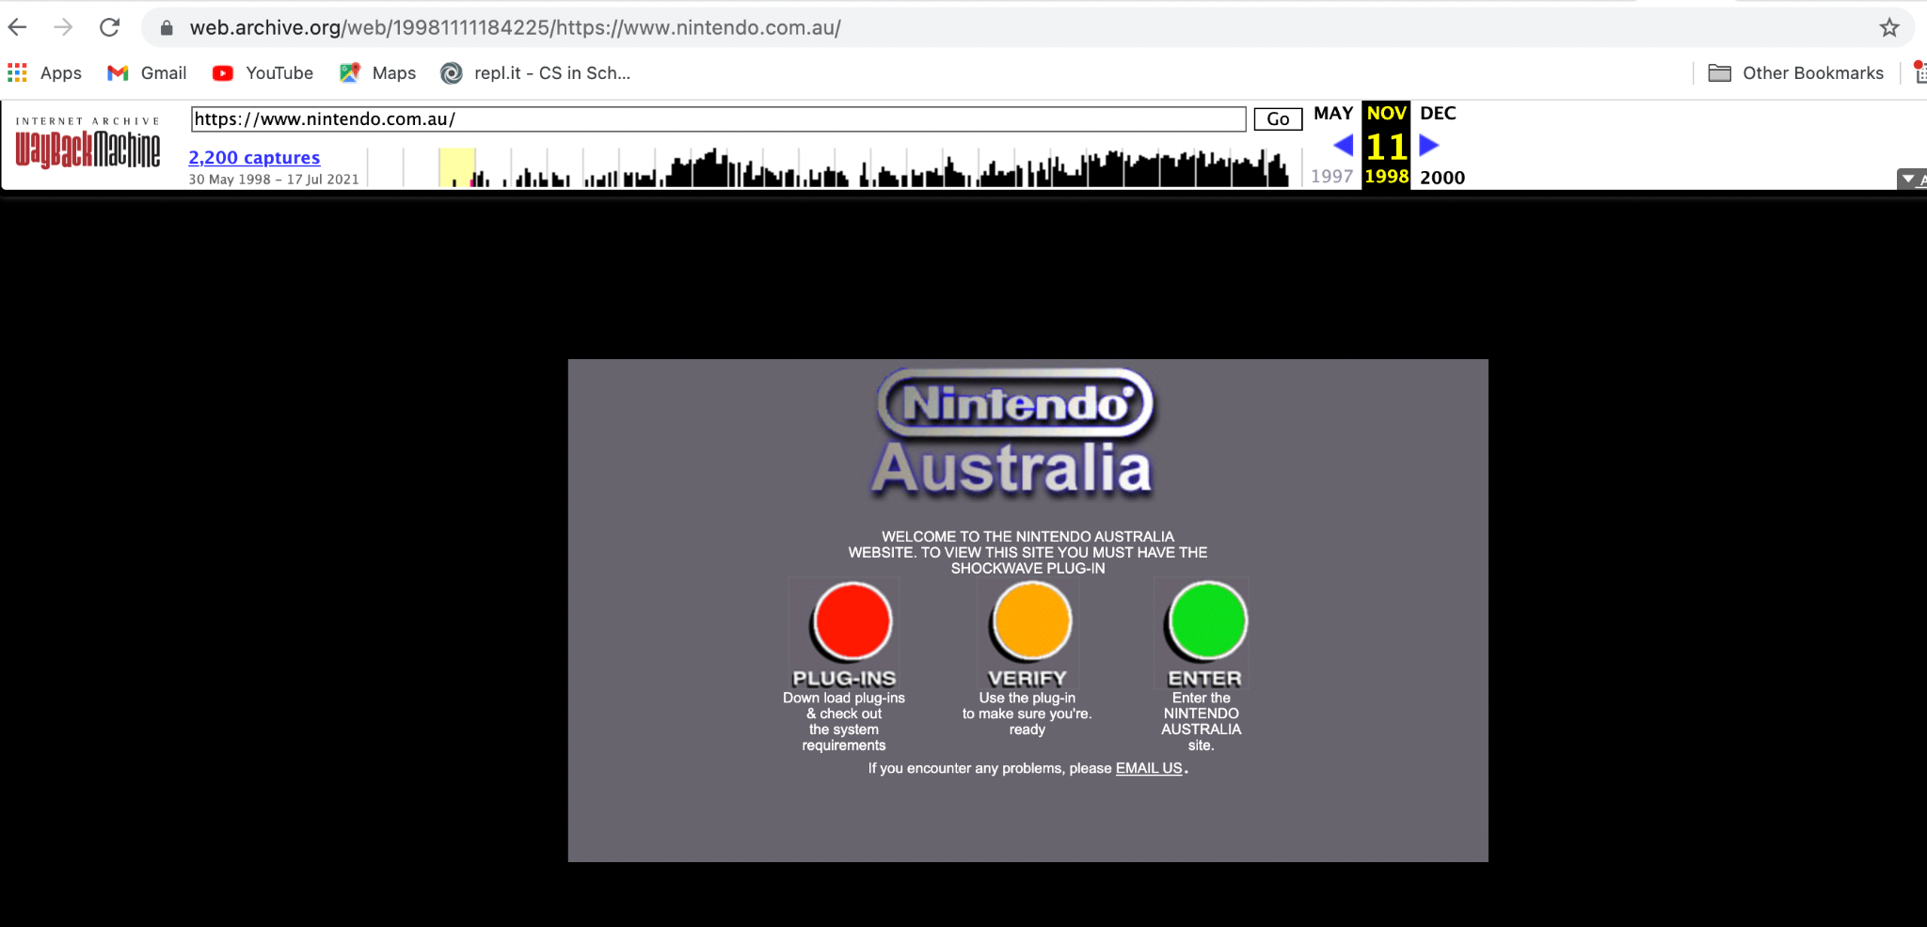 | 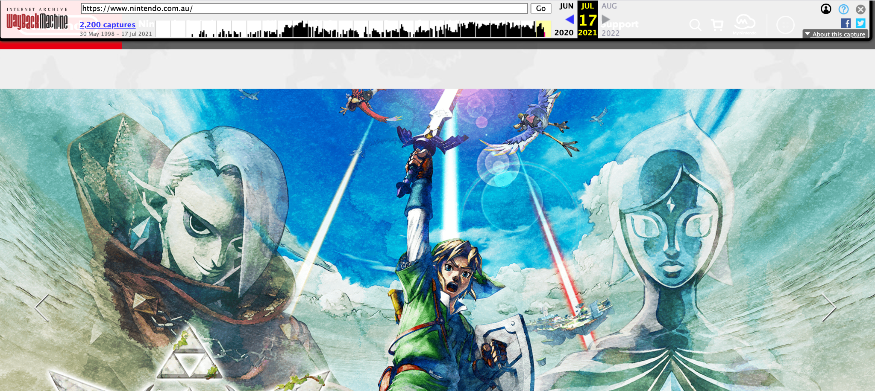

Time Travel Web Page Activity
 | Oldest website record | Website today
1. Your School
Website: [type in address]

2. Favourite Thing
Website: [type in address]

3. Australian Government
https://www.australia.gov.au/

4. The Great Barrier Reef
https://greatbarrierreef.org/

5. Apple
https://www.apple.com/

6. Adelaide Zoo
https://www.adelaidezoo.com.au/

7. Uluru
https://parksaustralia.gov.au/uluru/

8. Sydney Opera House
https://www.sydneyoperahouse.com/

9. Rottnest Island
https://www.rottnestisland.com/

10.Tasmanian Museum and Art Gallery
https://www.tmag.tas.gov.au/

Share your answers with your class.

