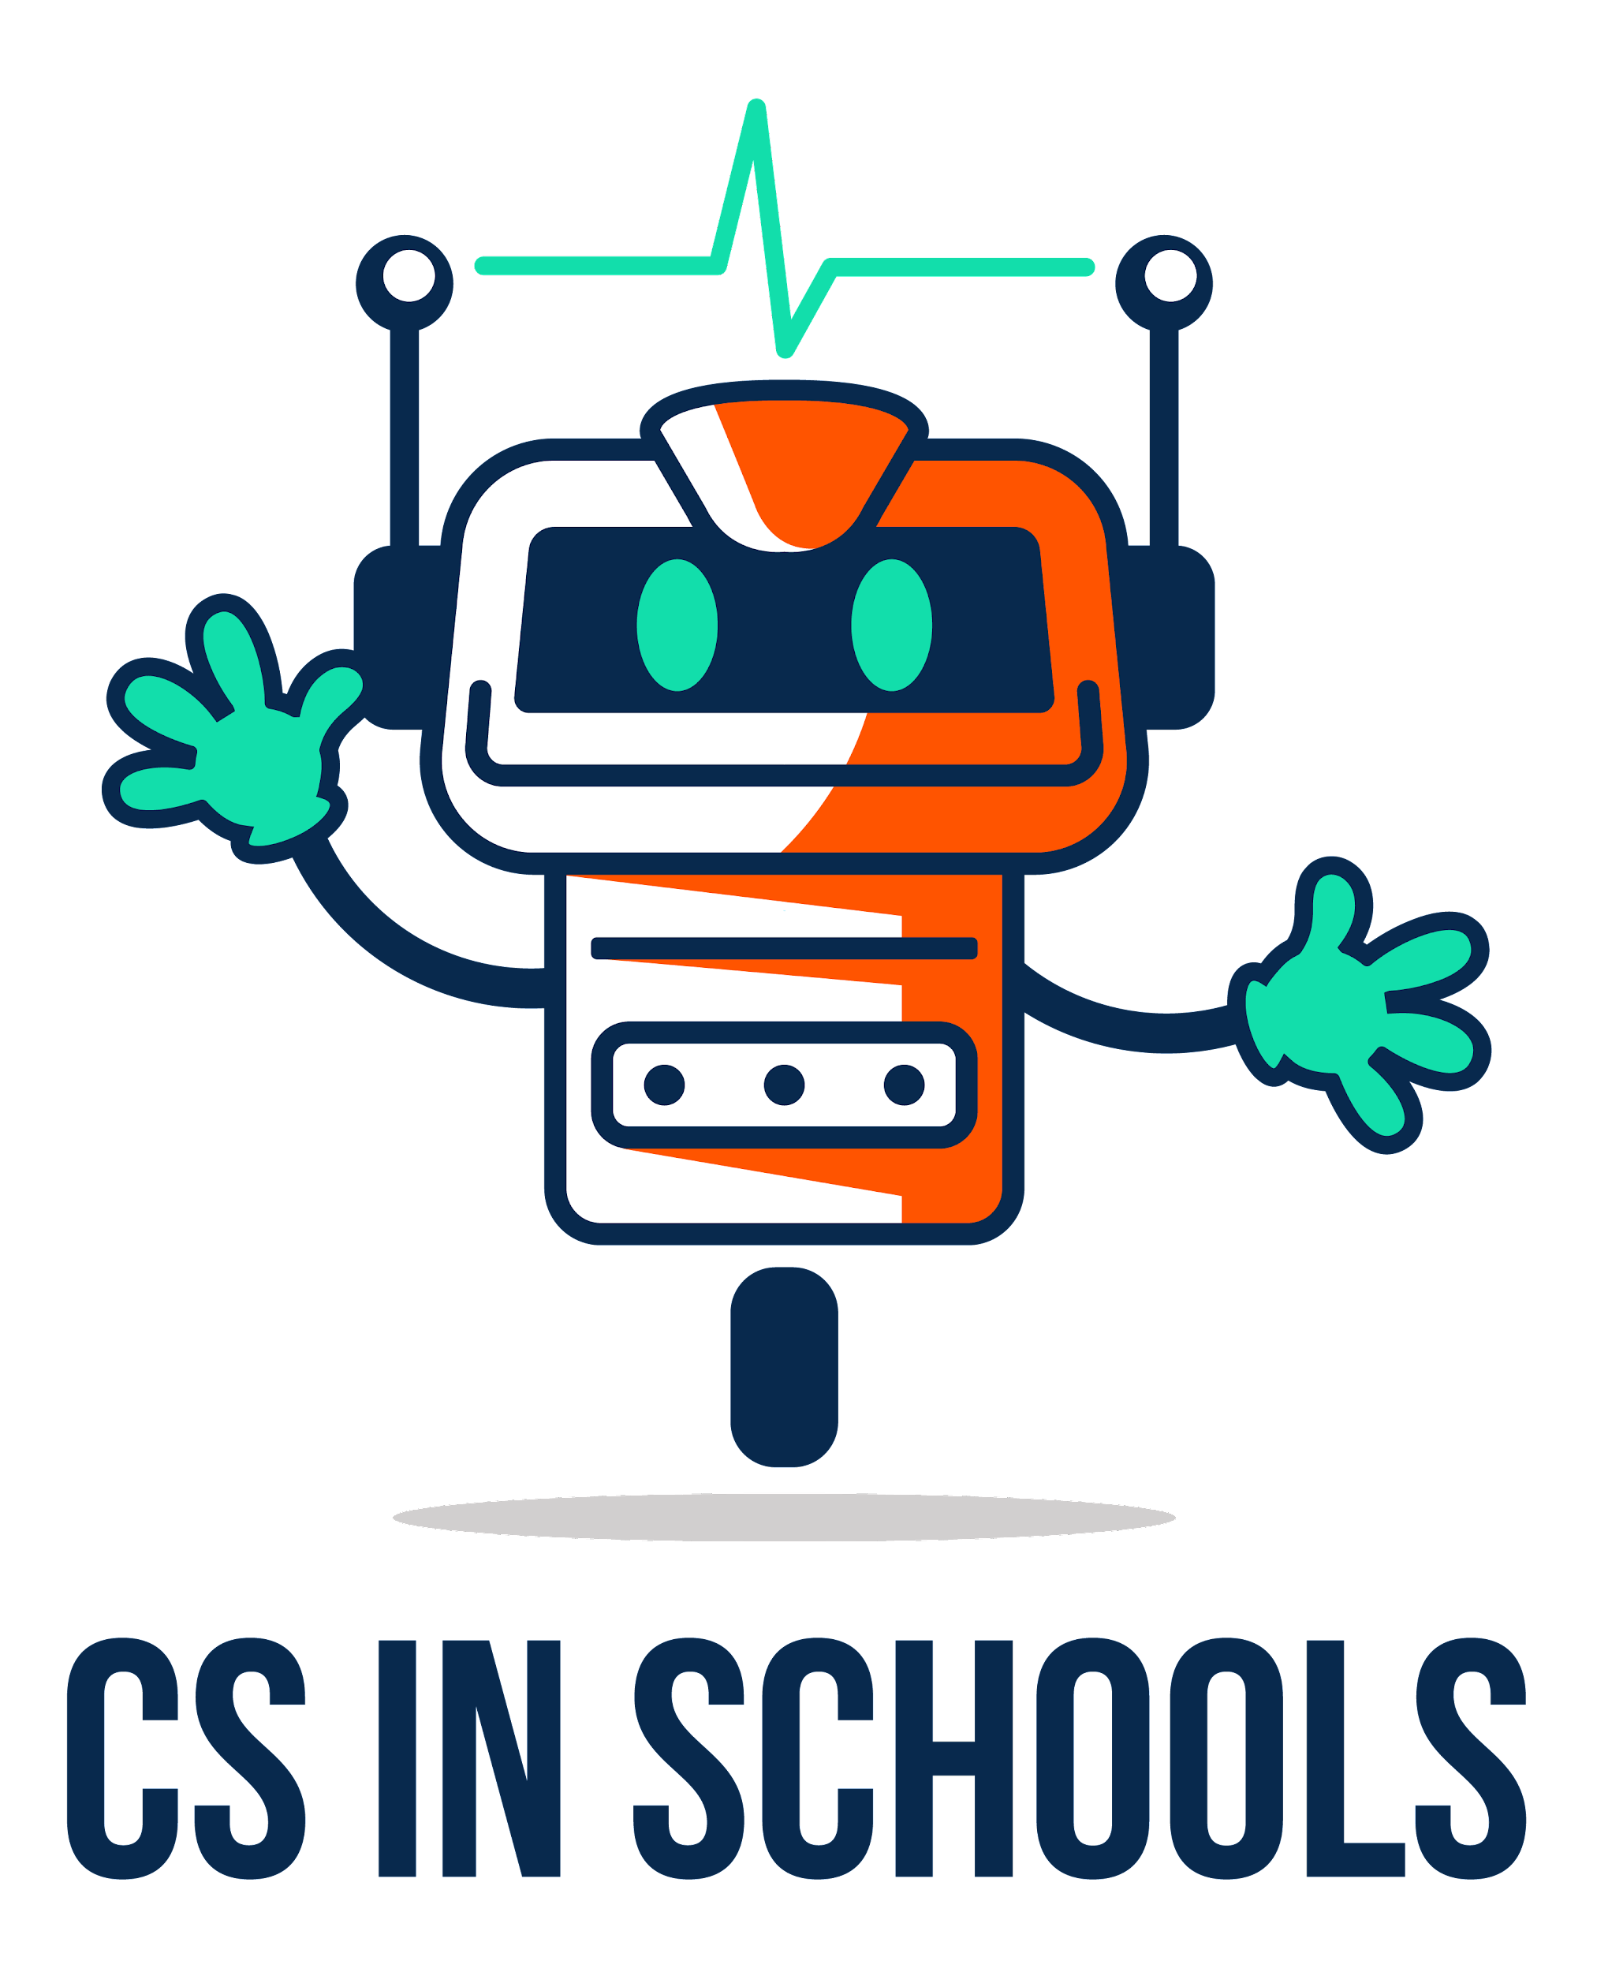
(Make your own copy by clicking the File menu, and then Make a copy)

Lesson 1: What is the Internet? Lingo Bingo

Name: | ................................................................................................................ | Class: | .............

Term | Definition
Internet | The Internet is a network of computers that are connected together
IP Address | A unique number assigned to each computer connected to a network
Web Browser | An application that is used to access the World Wide Web and can display web pages
Web Server | A web server is a computer that is connected to the Internet and receives requests (often from a web browser) for a particular web page. The web server decides on how to respond and this usually involves sending the web page back to the web server which will then display it
HTTP | HyperText Transfer Protocol specifies how a web browser and web server can communicate together
HTML | Stands for HyperText Markup Language and is used to describe the structure of a web page
URL | A URL (Uniform Resource Locator) specifies where a resource, such as a web page, can be found on the Internet
Query | A question or request for a specific web resource (e.g. web page, image file, video file…)
Download | A copy of a resource taken from the internet to your own device
DNS | Also known as Domain Name Service, this is a naming system for identifying computers, services and resources on that are connected to the Internet
Application | Any program on a digital device
Network | When two or more computers are connected together and communicate using common protocols
Website | A collection of webpages that are related and share the same domain name
Search | Finding the information you need using the Internet
Homepage | The default page of a website
Computer | An electronic device for storing and processing data

Instructions
- Click on this link to open up your unique ‘Internet-lingo Bingo!’ card.
- Once your teacher or volunteer is ready, they will read out a definition from the list above. Your job is to match the definition to a word on your bingo card (either from your memory or using the list above).
- If the word is on your bingo card, click it, and it will go green.
- If the word is not on your bingo card, don’t do anything.
- Once you get four green tiles in a row on your bingo card, shout “BINGO!” and you win!

Tips:
- Your teacher will be checking to make sure you haven’t ticked off any words incorrectly.
- If you accidentally click a tile, click it again and it will go back to the colour it was.
- If you need to reset your bingo card, click the “reset” button down the bottom - be careful though, this will reshuffle the words too!

