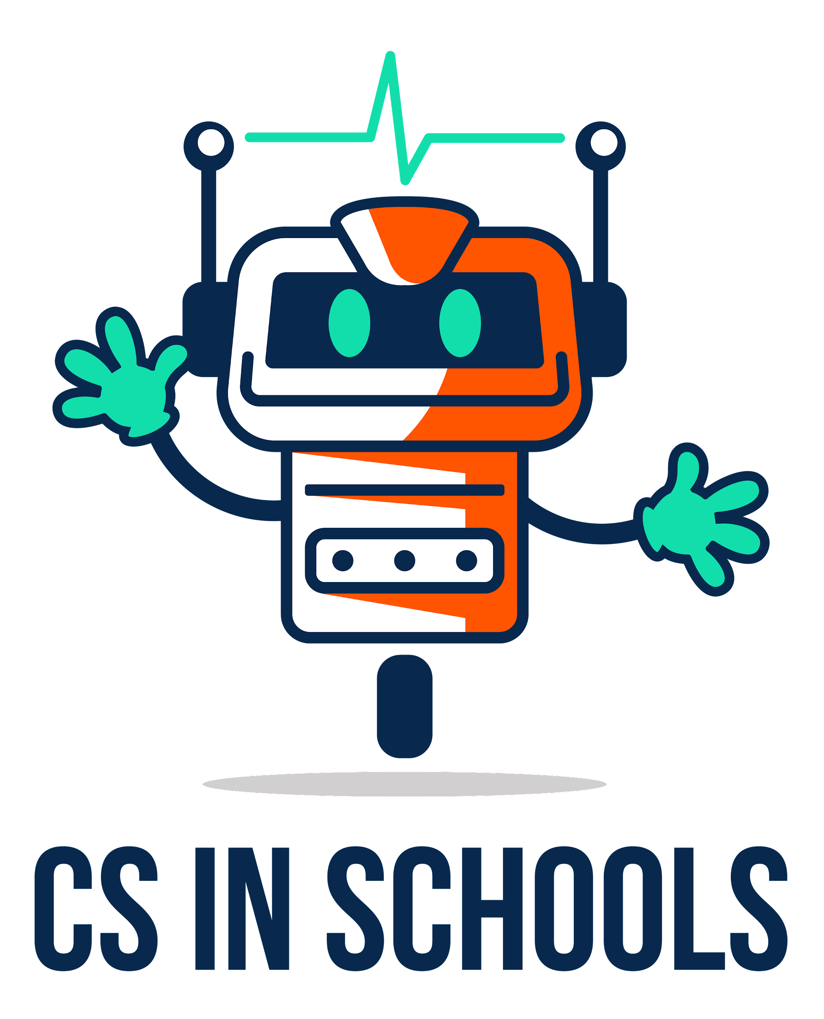
(Make your own copy by clicking the File menu, and then Make a copy)

Lesson 1: What is the Internet?
Name: | ................................................................................................................ | Class: | .............

Definitions
What is the Internet?

What is an IP address?

What is a web browser? Give 2 examples

What is a web server?

What does HTTP stand for and what does it do?

What does HTML stand for and what does it do?

What is a URL? Give 1 example

