
Worksheet: Turtle Graphics, Repeats
Name | .................................................................................
Class | .................................................................................

Question 1
Carefully look at the code below.
from turtle import *
repeat 4:
forward(50)
left(90)

- What do you think will be drawn by the turtle when the code above is run?

Now type in the code above and run the code (Start here @ https://csinschools.io/turtle )

Did it draw what you expected?

Question 2
The code below will draw a hexagon like this:
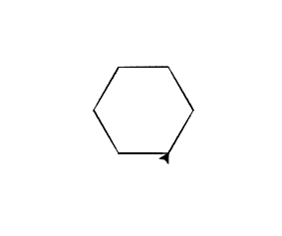

from turtle import *
forward(50)
left(60)
forward(50)
left(60)
forward(50)
left(60)
forward(50)
left(60)
forward(50)
left(60)
forward(50)
left(60)

By using the repeat keyword like in Question 1, rewrite the code so that it is shorter:

from turtle import *

Type in the code above and run the code to see if it works (Start @ https://csinschools.io/turtle )

Question 3
The code below will draw the following repeated pattern:
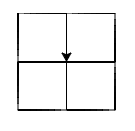
from turtle import *
forward(50)
left(90)
forward(50)
left(90)
forward(50)
left(90)
forward(50)
left(90)

left(90)

forward(50)
left(90)
forward(50)
left(90)
forward(50)
left(90)
forward(50)
left(90)

left(90)

forward(50)
left(90)
forward(50)
left(90)
forward(50)
left(90)
forward(50)
left(90)

left(90)

forward(50)
left(90)
forward(50)
left(90)
forward(50)
left(90)
forward(50)
left(90)

- Type in the code above and run the code to see the pattern (Start @ https://csinschools.io/turtle )
- Rewrite the code above using the repeat keyword to make it as short as you can:

from turtle import *

- Type in the code above and run the code to see if the same pattern is drawn (Start @ https://csinschools.io/turtle )

Question 4 - Extension

Using the repeat keyword, write down the code to draw the following pattern:
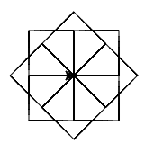

from turtle import *

- Type in the code above and run the code to see if the same pattern is drawn (Start @ https://csinschools.io/turtle )

