
Worksheet: Intro to Turtle Graphics
Name | .................................................................................
Class | .................................................................................

Question 1

Carefully look at the code below.
from turtle import *
forward(100)
left(90)
forward(100)

The teacher will run the code (The code is here @ https://csinschools.io/turtle )

When we run the code, the following graphic appears on the screen:
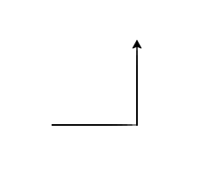

- What do you think the number 100 in the forward(100) instruction means?

- What do you think the number 90 in the left(90) instruction means?

Question 2

You would like to complete the code to draw a square like the one below:
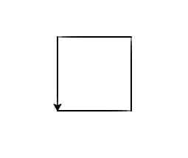

In the space below, write down the extra lines of code you think you would need to complete the drawing of the square.

from turtle import *
forward(100)
left(90)
forward(100)

The teacher will select a student’s answer and type it up on the screen @ https://csinschools.io/editor

Did it work?

The teacher will type up the correct answer and run it.

Question 3

In the Python editor at: https://csinschools.io/editor

Type in the correct code for Question 2 and run it to see the square!

Question 4

Change your code in the editor to draw a bigger square like the one below.
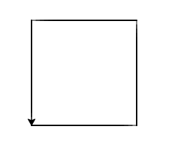

Question 5 - Extension

You’d like to draw a triangle like the one below:
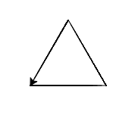

Write down below the instructions you think you’d need to draw the triangle.
from turtle import *

Show your written code to your teacher.

In the Python editor at: https://csinschools.io/editor, type in the code above and see if it works!
If it doesn’t work, keep on making changes to your code and see if you can get the answer!

