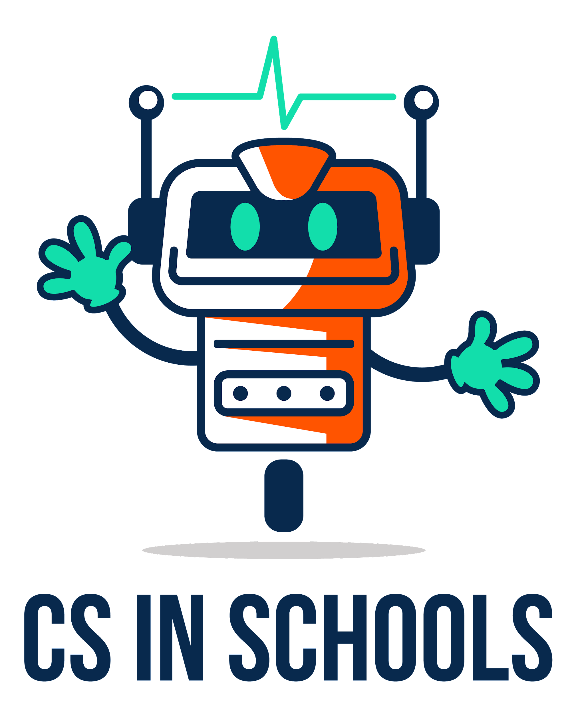
02.01 Variables and Functions
Name | .................................................................................
Class | .................................................................................

Question 1
What does a “string” mean in Python? (circle the correct option)
- A thin piece of rope
- A line of code
- Joining lines of code together
- A piece of text
- A long number

Question 2
What does it mean for a function to “return” something?
- It will go back to the code it started from
- It will give back a value when it finishes
- It will finish successfully
- It will automatically restart
- None of the above

Question 3
What does the input() function return?
- The text that the user typed in
- The text asking the user to type something in
- The code which runs after the user types something in
- The code which runs before the user types something in
- It doesn’t return anything

Question 4
For the code snippets below, highlight all the variables you can find.

Remember that variables:
- Do not have brackets afterwards (), and are not inside quotation marks “”
- Sometimes will have names starting with a noun (naming word)
- Always will be found to the left hand side of an = sign
- Sometimes can be found inside brackets and the right hand side of an =

It doesn’t matter if you don’t understand what the other parts of the code mean, if you use the above rules, you should still be able to identify the variables in the code.

movie = input("Enter the movie you’d like to watch:")
print("Now playing..." + movie)

height = listen("Say your height:")
if int(height) < 120:
say("You are not tall enough to go on this ride.")
else:
say("Welcome aboard!")

image = getWebCamImage()
objects = detectObjectsInImage(image)
if “car” in objects:
playBeep()

temp = getTemperature(address, device)
if temp > getHighSetting():
turnOnAC()
elif temp < getLowSetting():
turnOffAC()

Question 5
- In Python, the equals (=) sign is called the _________________ operator

- In the below line of code:
age = input("Enter your age: ")

What does Python run first? (circle the correct option)
  - input("Enter your age: ")
  - =
  - age

Question 6
- Josh would like to write some code to do the following:
- Ask the user to type in the drink they would like to order
- Store the user’s response into a variable called drink

Josh has written the following code:

input = print("What type of drink would you like?")
input = drink

Is this code correct or incorrect? _____________________

- Rewrite the code for Josh below so that it works correctly (see the first line of code in Question 1a if you would like a hint):

Question 7
- Write down Python code to achieve the following:
  - Ask the user to type in the name of a book they would like to buy
  - Store the user’s response into a variable called mybook

Question 8
- Write down Python code to achieve the following:
  - Ask the user to type in the name of a movie
  - Store the user’s response into a variable called mymovie
  - Display “Now playing… “ followed by whatever the user typed in earlier

- Type in the code above into the Python editor (https://csinschools.io/editor), run it and test that it works!

Question 9
- Write down Python code to achieve the following:
  - Ask the user to say the song they would like to hear
  - Store the user’s response into a variable called mysong
  - Say, in voice number 2, “Now playing <the song the user said>”

from goodies import say

- Type in the code above into the Python editor (https://csinschools.io/editor), run it and test that it works!

Question 10
- Write down Python code to achieve the following:
  - Ask the user to say the name of the city they are in
  - Store the user’s response into a variable called city
  - Say, in voice number 3, “The current temperature in <the city the user said> is 25 degrees.”

from goodies import say

- Type in the code above into the Python editor (https://csinschools.io/editor), run it and test that it works!

