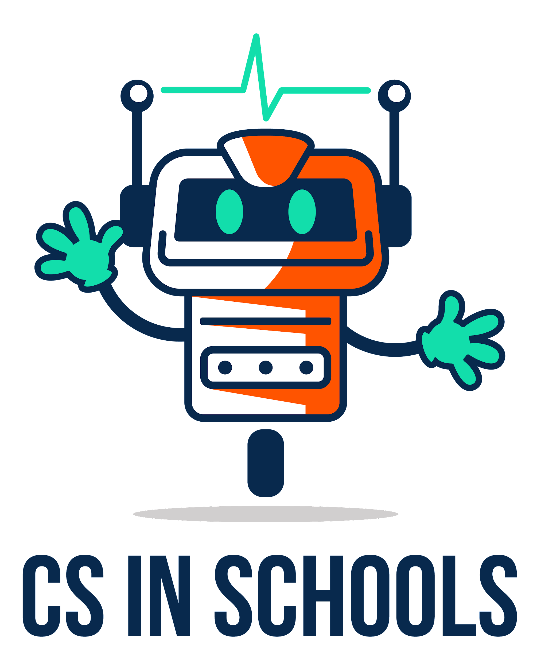
03.02 Worksheet - Cloud Variables
Name | .................................................................................
Class | .................................................................................

Question 1
- Find a partner!
- Write down the name of your cloud variable below.
It should follow the format of: cloud_firstname_lastname

- Write down the name of your partner’s cloud variable below:
It should follow the format of: cloud_firstname_lastname

- The student with the longer hair is the sender
- The student with the shorter hair is the receiver
- Write down whether you are the sender or the receiver: _________________
- Now head to opposite sides of the classroom!

Question 2
Step 1: For the receiver:
Type in the code below into the Python editor (https://csinschools.io/editor), replace
< partner’s cloud variable > with your partner’s cloud variable from Question 1c.

Remember to replace school_ID with the School ID given by your teacher.
from goodies import *
setSchool("school_ID")
print(partner’s cloud variable)

Run the code and check that you get an error (this is expected!)

Step 2: For the sender:
Type in the code below into the Python editor (https://csinschools.io/editor), replace
< your cloud variable > with your own cloud variable from Question 1b.

Remember to replace school_ID with the School ID given by your teacher.
from goodies import *
setSchool("school_ID")
your cloud variable = "Hello from across the room!"

Run the code.

Step 3: For the receiver:
Re-run your code and check that you got the message from your partner across the room!

Now switch roles (i.e. the sender becomes the receiver and the receiver becomes the sender) and repeat steps 1 - 3.

Question 3
With your partner:
- The student who is older is the sender
- The student who is younger is the receiver
- Write down whether you are the sender or the receiver: _________________

The sender will use the input function to ask the user to type in a message
The sender will assign the response into their own cloud variable
Write the sender code below:

The receiver will retrieve their partner’s cloud variable and say() it out aloud in voice number 2.
Write the receiver code:

Type in the code above into the Python editor (https://csinschools.io/editor), run it and test that it works!

Reverse roles and repeat.

Question 4
With your partner:
- The student who is shorter is the sender
- The student who is taller is the receiver
- Write down whether you are the sender or the receiver: _________________

The sender will use the listen function to ask the user to speak a message into the microphone.
The sender will assign the message into their own cloud variable
Write the sender code below:

The receiver will retrieve from their partner’s cloud variable and print() it onto the screen
Write the receiver code:

Type in the code above into the Python editor (https://csinschools.io/editor), run it and test that it works!

Reverse roles and repeat.

