Lesson/unit details | Creating Your Own Game Level in Ocado - Code for Life
Indicative behaviours  (observable evidence – what the student can say, make, do write) | 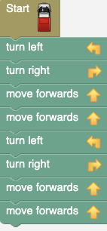  Sequence | Repeat block with numbers  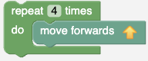 | Repeat block with conditions  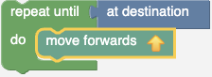 | Complexity of design route  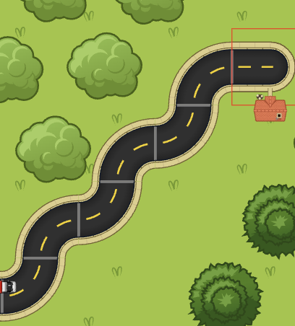 | Design features (scenery)  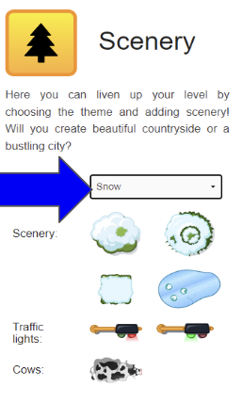
Quality criteria  are how well students display the indicator    (Increasing in difficulty bottom to top reflecting a progression for learning) | The game level has an algorithm which requires 15 or more blocks to complete. | Repeat code with numbers can be used in the game level 3 times | Route algorithm can be coded with two condition code blocks | The route has more than 5 turns.  (left or right) | The theme has been changed and there are 5 or more scenery features.
 | The game level has an algorithm which requires 10-14 blocks to complete. | Repeat code with numbers can be  used in the game level 2 times | Route algorithm can be coded with a condition block code. | The route has 3-4 turns .  (left or right) | There are 4 scenery features in the game design
 | The game level has an algorithm which requires 5-9 blocks to complete. | Repeat code with numbers can be used in the game level once. | Route algorithm can be coded with a condition block code. | The route has 2 turns .  (left or right) | There are 3 scenery features in the game design
 | The game level has an algorithm which requires less than 5 blocks to complete. | Repeat code with numbers can be used in the game level once. | Route algorithm can be coded with a condition block code. | The route has 0-1 turns .  (left or right) | There are 1-2 scenery features in the game design
 | Insufficient evidence | Insufficient evidence | Insufficient evidence | Insufficient evidence | Insufficient evidence
Capabilities  (learning outcome- what we want students to learn from the Vic Curric) | Digital Technologies / Levels 5 and 6 / Creating Digital Solutions  Students develop digital solutions as simple visual programs  Students design a user interface for a digital system, generating and considering alternative design ideas

