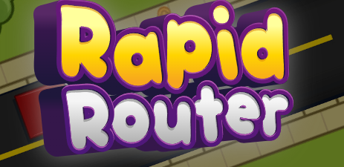
Post-Assessment Task: DESIGN A GAME LEVEL
Your task is to design a new game level for Rapid Router using pen and paper.

To demonstrate your learning you should try to include the following features:
- Repeat blocks with numbers
- Repeat blocks with conditions
- Left and right turns
- Scenery features

Here are some code blocks that you can use to build your map:

 |  | 
 | 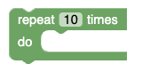 | 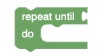

Scenery features that you can add:
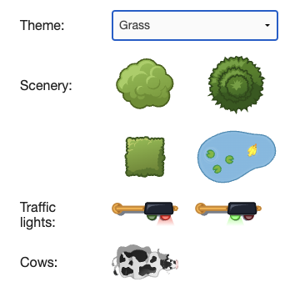

Draw your map on this grid:

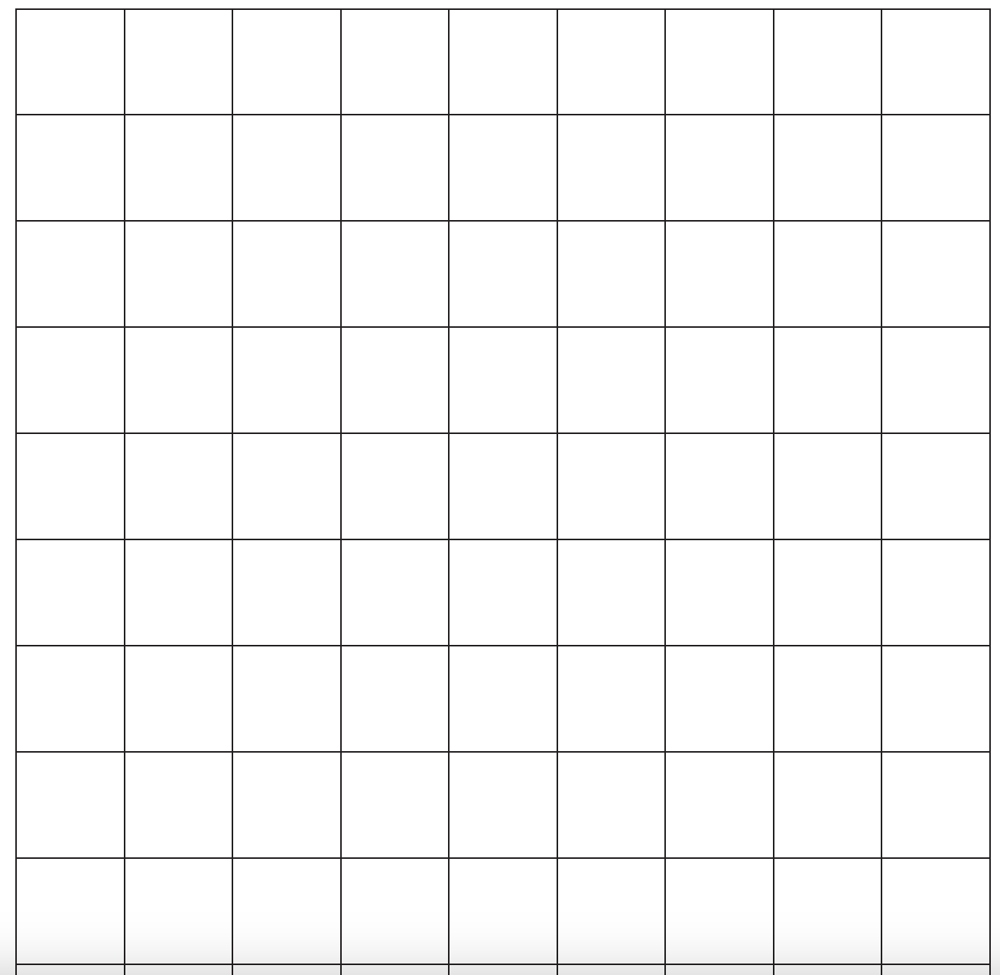

Record the code for your map here; check the features you need to include listed on the first page.

