06.03 Worksheet - Drawing a Route
Carefully examine the Rapid Router algorithm below:
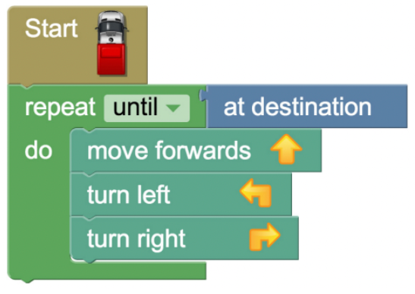
In the space below, draw a route which a van following the above algorithm will take.
Remember to include the starting and ending places.

Draw another route which the van could take following the same algorithm as above!

