06.01 Worksheet - Playing Snap
Consider the following algorithm for playing the game of snap:
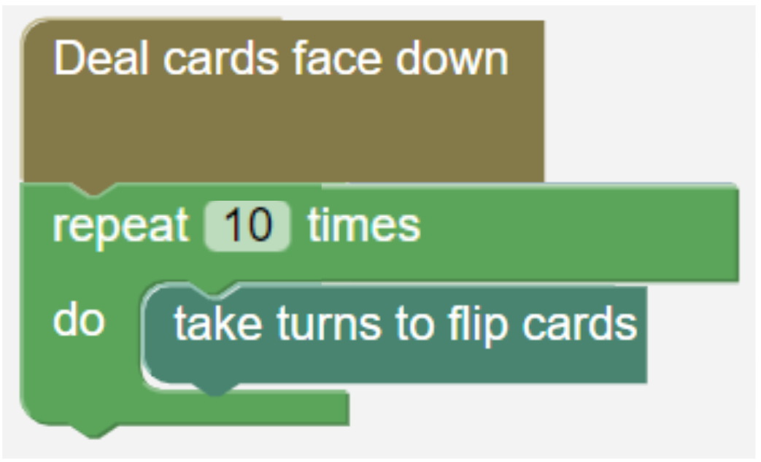
- What is a problem with this algorithm and why might it not work correctly?

- Consider the blocks below:
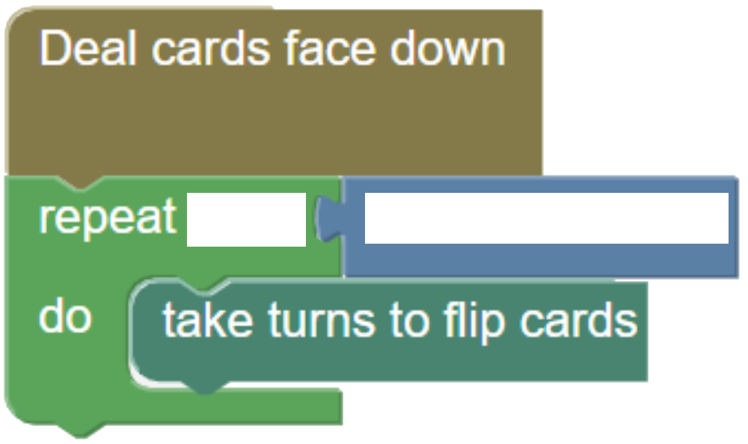
By filling in the black spaces, construct an algorithm which will work for playing snap.

