05.01 Worksheet - Nesting Coloured Beads
Carefully examine the length of coloured beads below:
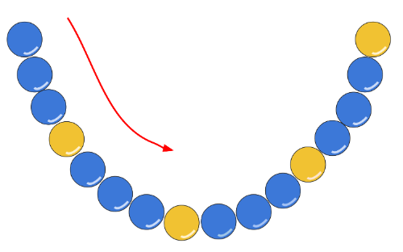
By using nested repeat blocks, write an algorithm below which describes how to lay out these beads using the fewest number of blocks:
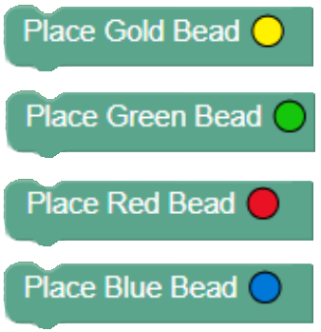
Below are some blocks you may use:
