It’s Raining Tacos- Key
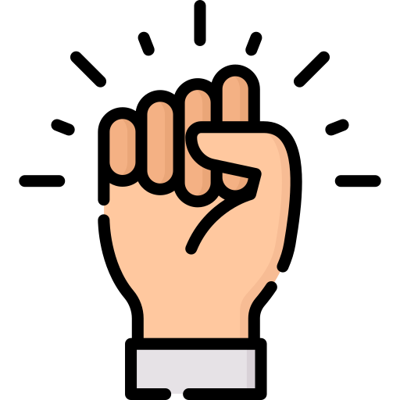  pound fist on desk | 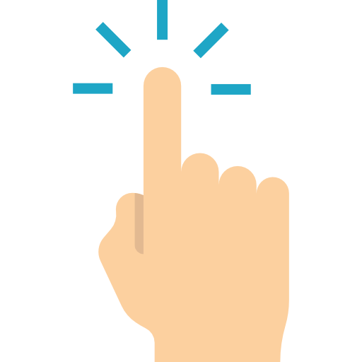  tap your finger and say “boop” | 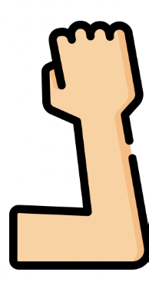  tap your elbow on your desk | 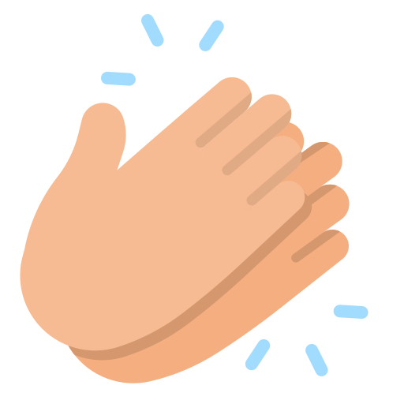  clap your hands
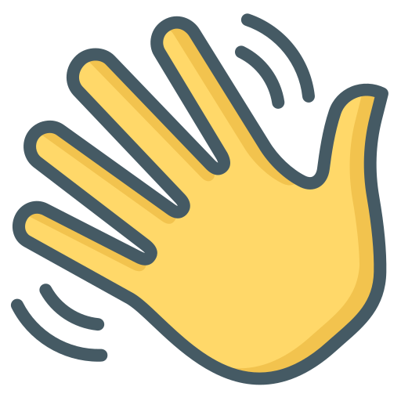  put your hand on your desk | 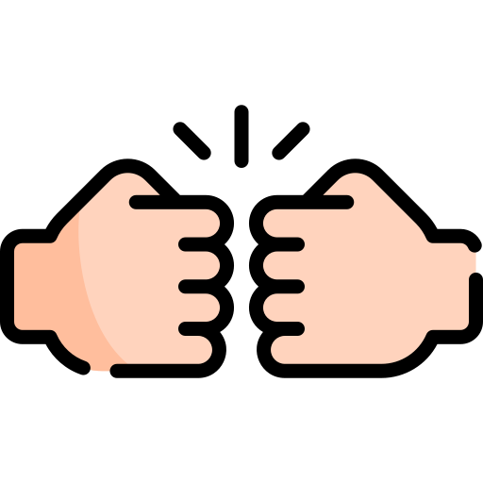pound both fists on your desk |  | 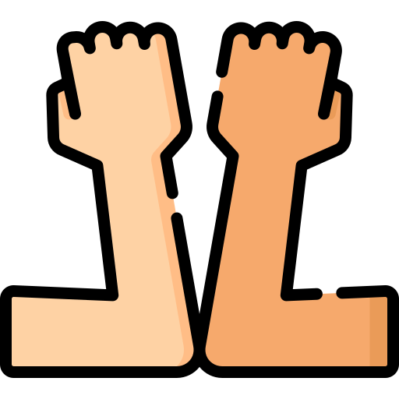  tap both elbows on your desk

= pound fist on desk | = pound fist on desk | =tap your finger and say “boop” | =tap your finger and say “boop” | =tap your elbow on your desk | =tap your elbow on your desk | =clap your hands | =clap your hands
= pound fist on desk | = pound fist on desk | =tap your finger and say “boop” | =tap your finger and say “boop” | =tap your elbow on your desk | =tap your elbow on your desk | =clap your hands | =clap your hands
= pound fist on desk | = pound fist on desk | =tap your finger and say “boop” | =tap your finger and say “boop” | =tap your elbow on your desk | =tap your elbow on your desk | =clap your hands | =clap your hands
= pound fist on desk | = pound fist on desk | =tap your finger and say “boop” | =tap your finger and say “boop” | =tap your elbow on your desk | =tap your elbow on your desk | =clap your hands | =clap your hands
=put your hand on your desk | =put your hand on your desk | =put your hand on your desk
=put your hand on your desk | =put your hand on your desk | =put your hand on your desk

