How to Make a Cup of Tea

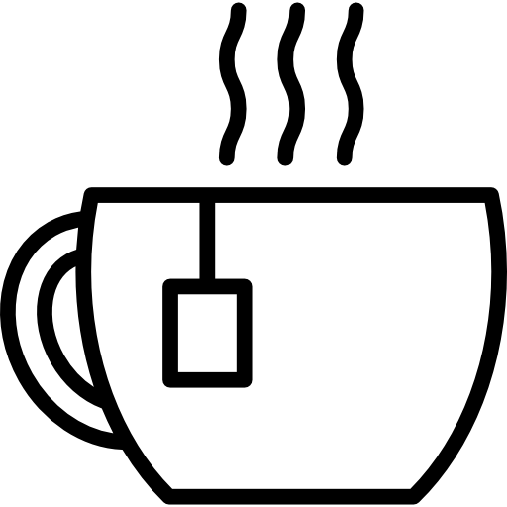
Sequence the following instructions to make a cup of tea.
Place numbers in front of each instruction to show the correct order.

Stir the tea
Pour boiling water into the mug
Add milk and sugar to taste.
Place a tea bag into a mug
Fill up the kettle with water
Brew the tea for a few moments
Enjoy the hot beverage
Boil the kettle
Remove and dispose of the teabag

