
02.01 Worksheet: Drawing Flowcharts
Name | .................................................................................
Class | .................................................................................

Question 1
Draw arrows to match up the following flowchart shapes with their correct names.

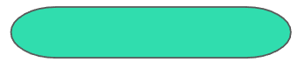 |  | Input or Output
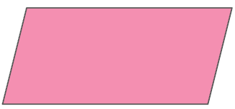 |  | Decision
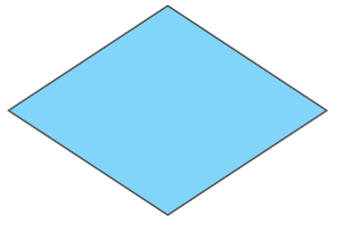 |  | Terminal

Question 2
We would like to draw a flowchart for an algorithm which will determine whether a shape that someone thinks of is a triangle.
- If the shape has 3 sides, the algorithm should display “It is a triangle!”.
- If the shape does not have 3 sides, the algorithm should display “It is not a triangle!”.

Complete the flowchart below so that the algorithm is complete and correct.

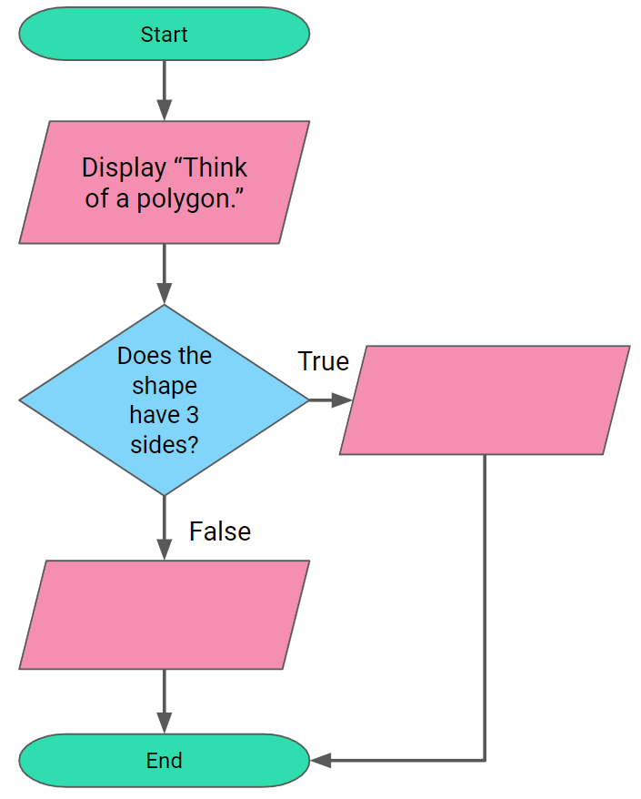
Question 3
We would like to draw a flowchart for an algorithm which will determine whether a shape that someone thinks of is a regular polygon.
- A regular polygon is a polygon with all its sides having equal length.

Complete the flowchart below so that the algorithm is complete and correct.

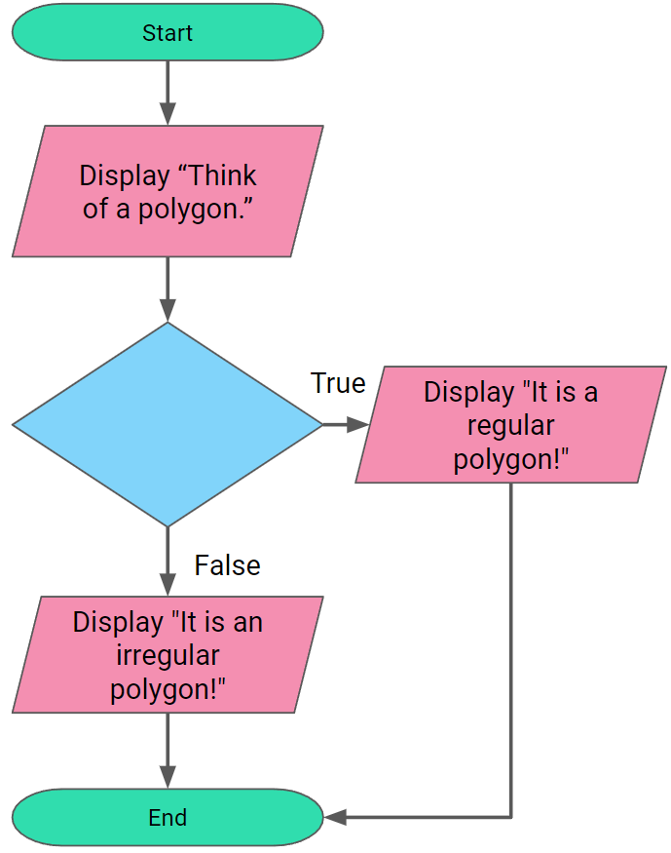
Question 4
We would like to draw a flowchart for an algorithm which will determine whether a polygon that someone thinks of is a pentagon. A pentagon is a polygon with 5 sides.
- Ask the user to think of a polygon.
- If the shape has 5 sides, the algorithm should display “It is a pentagon!”.
- If the shape does not have 5 sides, the algorithm should display “It is not a pentagon!”.

Fill in the shapes in the flowchart below to represent the above algorithm.
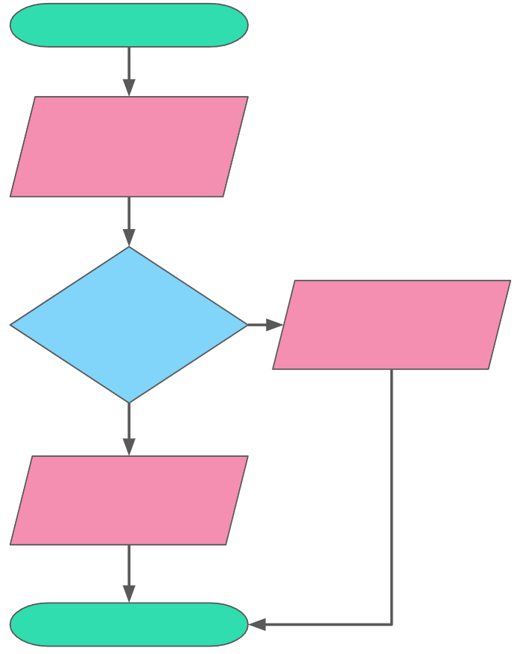

Question 5
Draw a flowchart for the algorithm below:
- Ask the user to think of an integer.
- If the integer is even, the algorithm should display “It is divisible by 2”.
- If the integer is not even, the algorithm should display “It is not divisible by 2”.

Question 6
Draw a flowchart for the algorithm below:
- Ask the user to think of an integer.
- If the number ends in 0 or 5, the algorithm should display “It is divisible by 5”.
- If the number does not end in 0 or 5, the algorithm should display “It is not divisible by 5”.

