
01.01 Worksheet: Drawing Flowcharts
Name | .................................................................................
Class | .................................................................................

Question 1
In the flowchart diagram below, fill in the missing words within the terminal shapes
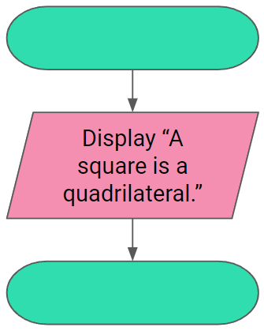
Write down below what you think the above algorithm does.

Question 2
Fill in the missing words in the flowchart below to complete an algorithm which displays “An isosceles triangle has 2 equal sides.”
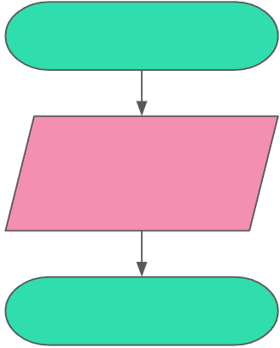

Question 3
In the space below, draw the flowchart diagram for an algorithm which displays “A 90° angle is called a right angle.”

Question 4
Describe what the following algorithm does:
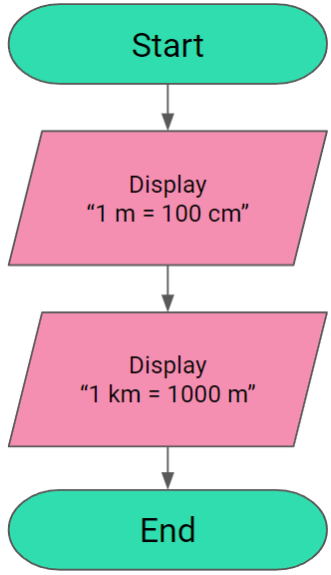

Question 5
In the space below, draw the flowchart diagram for an algorithm which displays the following two statements:
1 kg = 1000 g
1 ton = 1000 kg

Question 6
In the space below, draw the flowchart diagram for an algorithm which displays the following three statements:
All cats have whiskers.
A lion is a cat.
Therefore a lion has whiskers.

