
(Make your own copy by clicking the File menu, and then Make a copy)

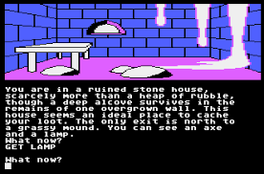
Assignment - A Simple Text Adventure Game

Name | .................................................................................
Class | .................................................................................

Recommended working duration: 2 weeks
Your task is to program a simple text adventure game similar to these two examples:

- City of Gold
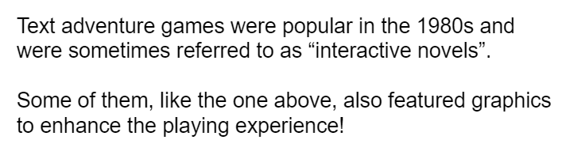
- Your Spirit Animal

Your game needs to contain at least five scenes with at least two choices in each scene. Example scenes could be rooms, locations, battles, situations, questions, and so on.
More than one choice from different scenes can lead to the same scene.
You must be able to finish the game!
Using colours in your game is encouraged. You could also optionally draw graphics, clear the screen, and use other visual ideas to make your game appealing.
Please see the above two games as examples. There is also some starting template code, and an accompanying video guide that you might find helpful.

Assessment Areas
You will be assessed on the following areas.

Number of Scenes
Your game needs to have at least five scenes

Number of Choices
Your five scenes must allow the user to make at least two choices.

Game Completion
We must be able to complete your game without any errors.

Creativity - Storyline
You will be awarded marks for creativity in the story.

Creativity - Presentation
You will be awarded marks for creativity in your layout and presentation (use of colours, special characters, screen clearing, and so on).

Marking Rubric

 | High (3) | Medium (2) | Low (1) | Not Shown (0)
Number of Scenes | More than 5 scenes were demonstrated | 5 scenes were demonstrated | Less than 5 scenes were demonstrated | The game did not run
Number of Choices | At least 5 scenes had at least 2 choices | Between 2 and 4 scenes had at least 2 choices | Only 1 or no scenes had choices | The game did not run
Game Completion | The game can be completed successfully without any bugs | The game can be completed with some bugs | The game can be completed with a lot of bugs | The game cannot be completed
Creativity Storyline | A highly creative and original story or game was built | A standard but workable game and storyline | The storyline was difficult to understand | The game did not run
Creativity - Presentation | Colours and screen effects were used and were suited to the game | Some colours and screen effects were used but more would have been appropriate | The game did not use colour or other effects at all | The game did not run

License Information
These CS in Schools lessons plans, worksheets, and other materials were created by Toan Huynh and Hugh Williams. They are licensed under a Creative Commons Attribution-ShareAlike 4.0 International License.

