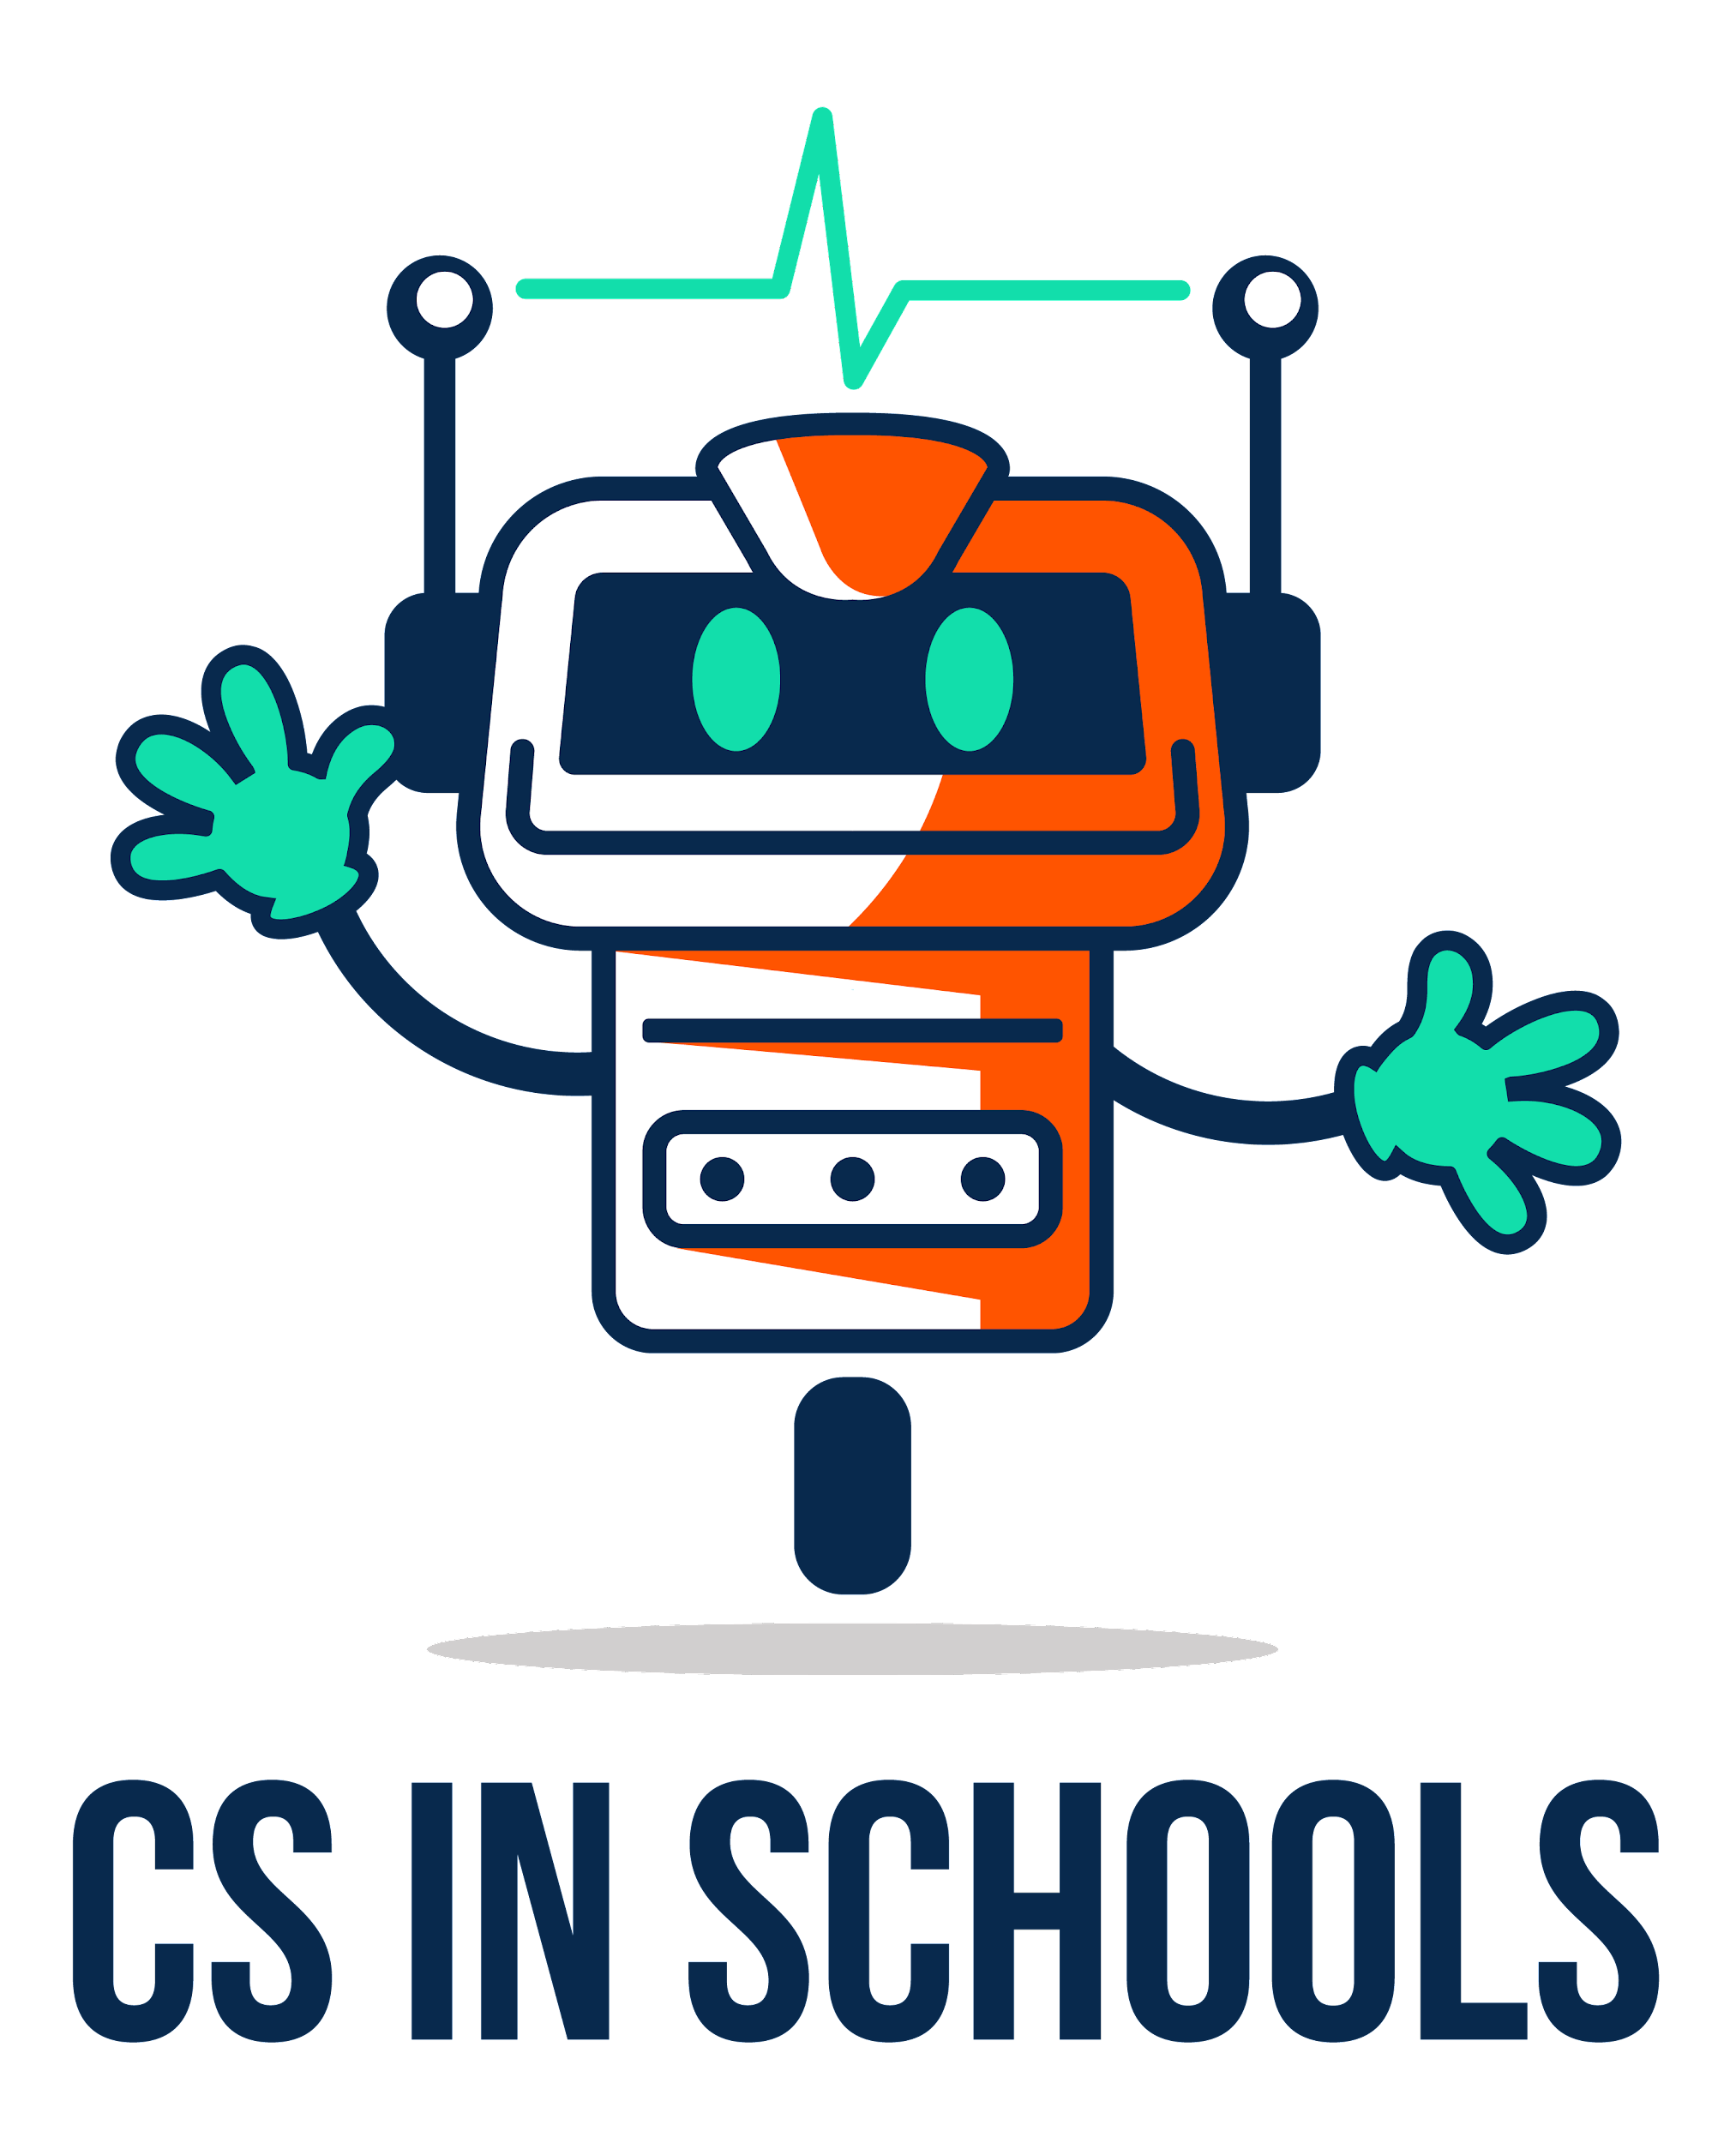
(Make your own copy by clicking the File menu, and then Make a copy)

Alternative Assignment - A Simple Text Animation
Name | .................................................................................
Class | .................................................................................
Recommended working duration: 2 weeks

Your task is to program a simple text animation similar to these two examples below:
- Sample Movie Trailer
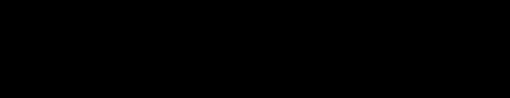
- Sample Story Intro (from actual student work!)

Your animation needs to contain:
- Colours
- ASCII art (see below links for some handy ASCII art resources, feel free to look for more!)
  - ASCII Art Archive
  - Text to ASCII
- Clearing the screen
- Pauses
Please see the above two programs as examples. There is an accompanying video guide (2:03 mins) and starter code that you might find helpful.

Assessment Areas
You will be assessed on the following areas.

Colours
Your animation will need to demonstrate usage of different colours, highlights and/or styles

ASCII Art
Your animation will need to demonstrate usage of ASCII art

Clearing the Screen
Your animation will need to clear the screen at least once

Pauses
Your animation will need to demonstrate the effective use of pauses

Creativity - Originality and Presentation
You will be awarded marks for creativity in .

Marking Rubric
 | High (2) |  | Low (1) | Not Shown (0)
Colours | The animation demonstrated colours / highlights / styles in a highly engaging manner |  | The animation demonstrated a change in colour / highlight / style | The animation did not use any colours / highlights / styles
 | High (2) |  | Low (1) | Not Shown (0)
ASCII Art | The animation demonstrates usage of ASCII art in a highly engaging manner |  | The animation demonstrates usage of ASCII art | The animation demonstrates usage of ASCII art
 | High (1) |  |  | Not Shown (0)
Clearing the Screen | The animation demonstrates usage of clearing the screen |  |  | The animation does not clear the screen
 | High (2) |  | Low (1) | Not Shown (0)
Pauses | The animation demonstrates pauses in a highly engaging manner |  | The animation demonstrates pauses | The animation does not demonstrate any pauses.
 | High (3) | Medium (2) | Low (1) | Not Shown (0)
Creativity - Originality | The animation demonstrates high levels of originality and creativity | The animation is original and creative | The animation is basic and/or similar to the examples provided | The animation did not run

License Information
These CS in Schools lessons plans, worksheets, and other materials were created by Toan Huynh and Hugh Williams. They are licensed under a Creative Commons Attribution-ShareAlike 4.0 International License.

