
(Make your own copy by clicking the File menu, and then Make a copy)

Worksheet 01.01 - Introduction to CS in Schools
Name | .................................................................................
Class | .................................................................................

Out of a scale of 1 to 5, how much programming have you done before?
(5 = I program often in my spare time, 1 = what is programming??)

Write down 3 areas where computers make an impact on your life.
1)

2)

3)

If you could make computers do anything you want, write down 3 things that you would like them to do.
1)

2)

3)

Continued on the next page…
Introduction to Coding: Scavenger Hunt
- Using your preferred search engine, respond in full sentences and complete the following activity
- Once complete, share your answers with the class
PART 1: Technology & Life
Identify 1 way technology impacts the following areas of our daily lives. Include a specific example for each:
- Around the home | 1.
- Health | 2.
- Communication | 3.
- Appliances and devices | 4.
- Travel | 5.
- Entertainment | 6.



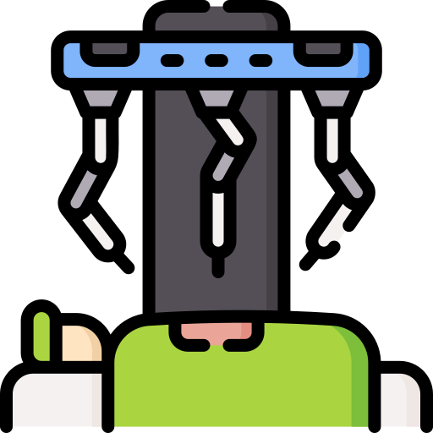

PART 2: Digital Detective (A)
- Using your preferred search engine, fill in the table below with full sentences.
- You can fill out this table, or jump onto the next page to complete the case file - if you would prefer!
Questions | Answers
In what year was the Python programming language formally released?
Who is the person credited with developing Python?
What is this person's age?
How many siblings do they have?
Upload a picture of this person.








PART 2: Digital Detective [b]
- Using your preferred search engine, fill in the case file below:
  - “<YEAR OF CREATION>” - replaced with the year Python was invented by double clicking on it
  - “DETAILS ABOUT CREATOR” - fill in all the blanks by double clicking on them
  - “IMAGE OF CREATOR” - cover the box with an image of the creator of Python language

Details about creator
Name:
Age:
Location:
Number of Siblings:

IMAGE OF CREATOR
Python: <Year of Creation>
PART 3: Communicating with Python
- Using your preferred search engine, fill in the table below with full sentences.
Questions | Answers
Provide 2 reasons why Python is a popular coding language today.
What does the word syntax mean (in reference to computers)?
Why is syntax important when coding?




print(“sss”)

Hello

License Information
This material was created by the team at CS in Schools. It is licensed under a Creative Commons Attribution-ShareAlike 4.0 International License.

