
(Make your own copy by clicking the File menu, and then Make a copy)

Worksheet 01.03 - Coordinates
Name | .................................................................................
Class | .................................................................................


Using the grid on the next page, follow the instructions below…
- Draw a line between (0, 80) and (400, 80)

- Draw a line between (100, 80) and (100, 250)
- ​​Draw a line between (300, 80) and (300, 250)
- Draw a line between (80, 250) and (320, 250)
- Draw a line between (80, 250) and (200, 320)
- Draw a line between (320, 250) and (200, 320)
- Draw a point at (120, 180), then a square with width 50 and height 50 - the bottom left corner should be at the point (120, 180)
- Draw a point at (220, 80), then a rectangle with width 50 and height 100 - the bottom left corner should be at the point (220, 80)

Can you improve this?
HINT: Steps 2 and 3 can be done in one line! So can Steps 4, 5 and 6

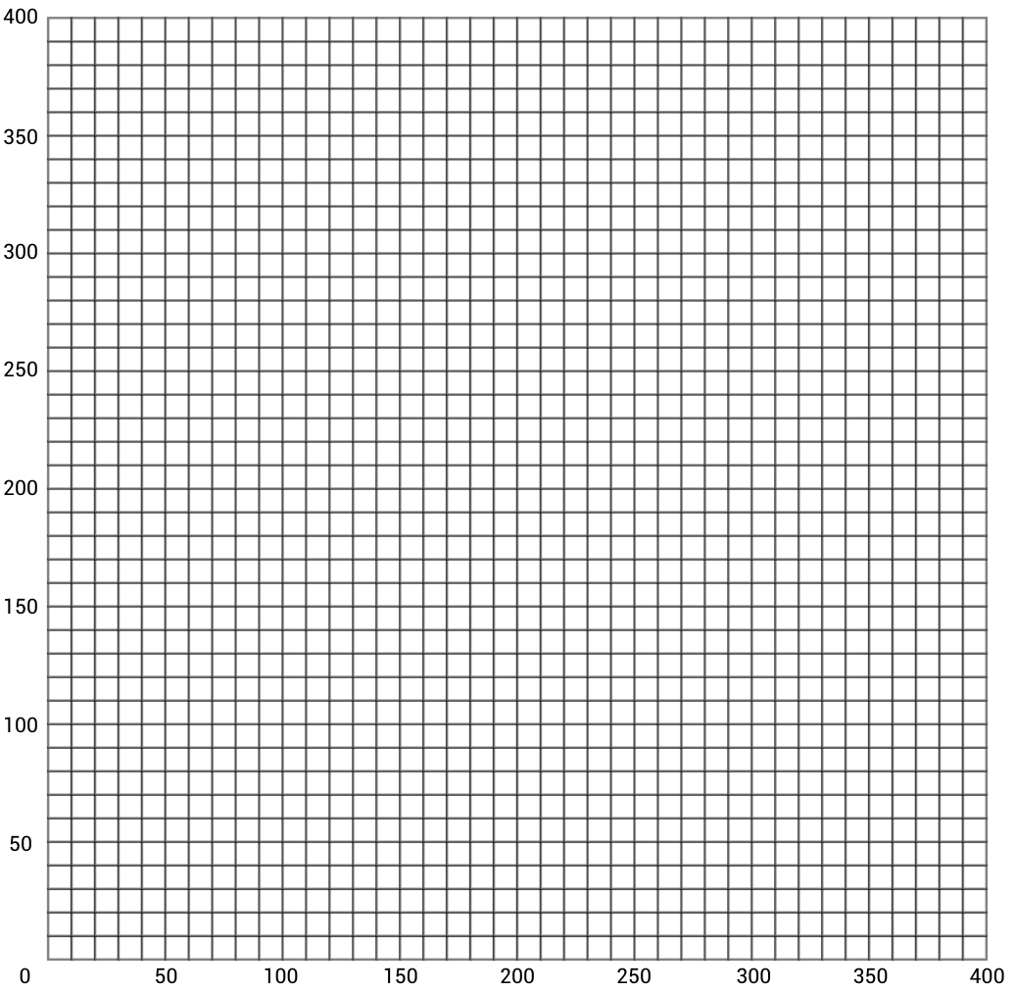
License Information
This material was created by the team at CS in Schools. It is licensed under a Creative Commons Attribution-ShareAlike 4.0 International License.

