
Worksheet: Turtle Graphics and Angles
Name | .................................................................................
Class | .................................................................................

Question 1

Type of angle: | Type of angle:  Right Angle | Type of angle: | Type of angle:
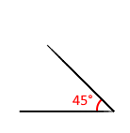 | 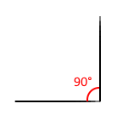 | 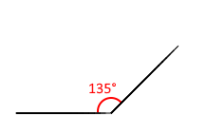 | 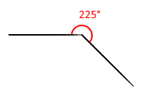
Python Turtle code:  from turtle import *  forward(100) | Python Turtle code:  from turtle import *  forward(100)  left(90)  forward(100) | Python Turtle code:  from turtle import *  forward(100) | Python Turtle code:  from turtle import *  forward(100)

Once you are finished, go to https://csinschools.io/python/turtle, type in your code and see if it works!

If your code doesn’t work at first, keep making changes to the code and re-running it until you get the correct answer. Then rewrite the correct answer in the table above.

Question 2
You may have noticed that the angle you use in the turtle code is different to the angle you used to draw the angles using a protractor.

In the space below, describe how the angle values in the turtle code is different to measured angles using protractors.

