
03.01 Worksheet: Compound Boolean Conditions
Name | .................................................................................
Class | .................................................................................
Question 1
Consider the flowchart below. Then fill in the table with what you would expect the algorithm to display depending on the given values of the age and money variables.
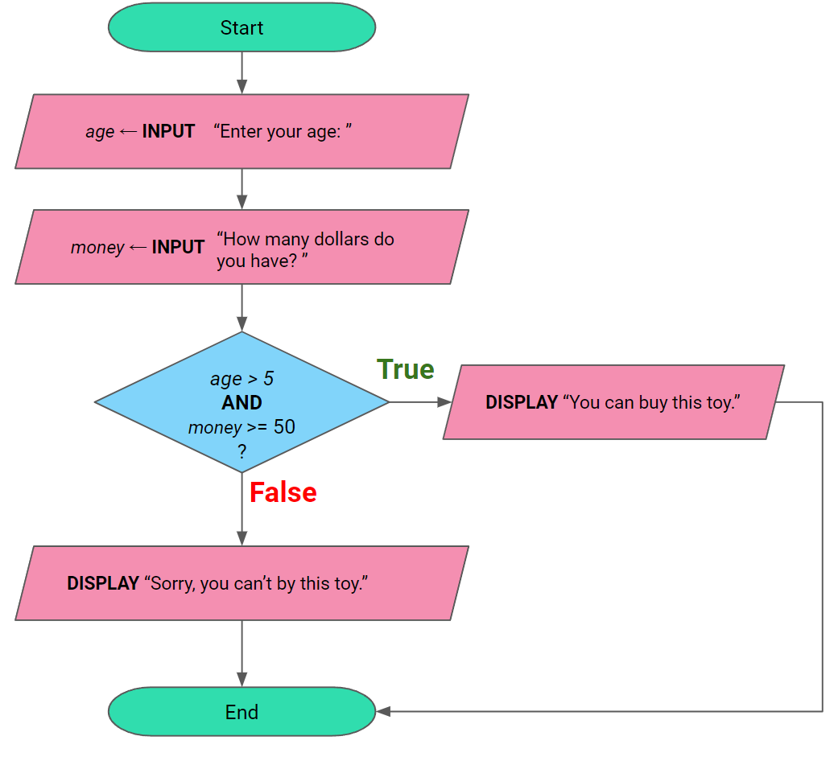

age | money | What will be displayed?
10 | 40 | Sorry, you can’t buy this toy.
20 | 100 | You can buy this toy.
5 | 50
2 | 100
6 | 49
8 | 50

Question 2
The flowchart for the algorithm below will authorise the credit card if the credit card number is 4321 5678 0987 6543 and the CVC code is 931. Complete the flowchart so the algorithm works correctly.

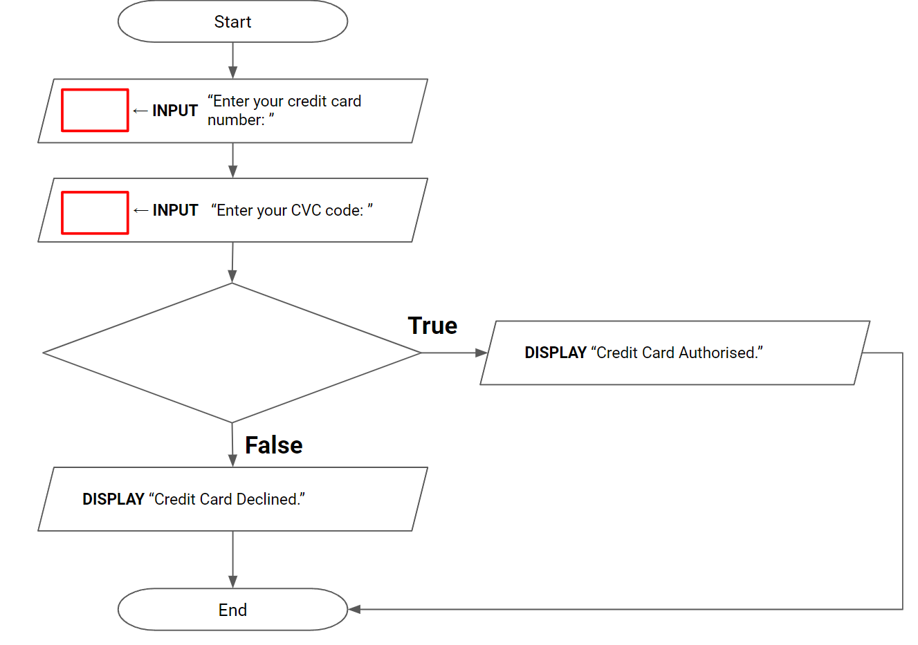

Question 3
An online store will offer free delivery for all addresses with postcodes between 3100 and 3199 inclusive. Complete the flowchart below for an algorithm which asks for the user’s postcode and then displays whether or not they are eligible for free delivery.

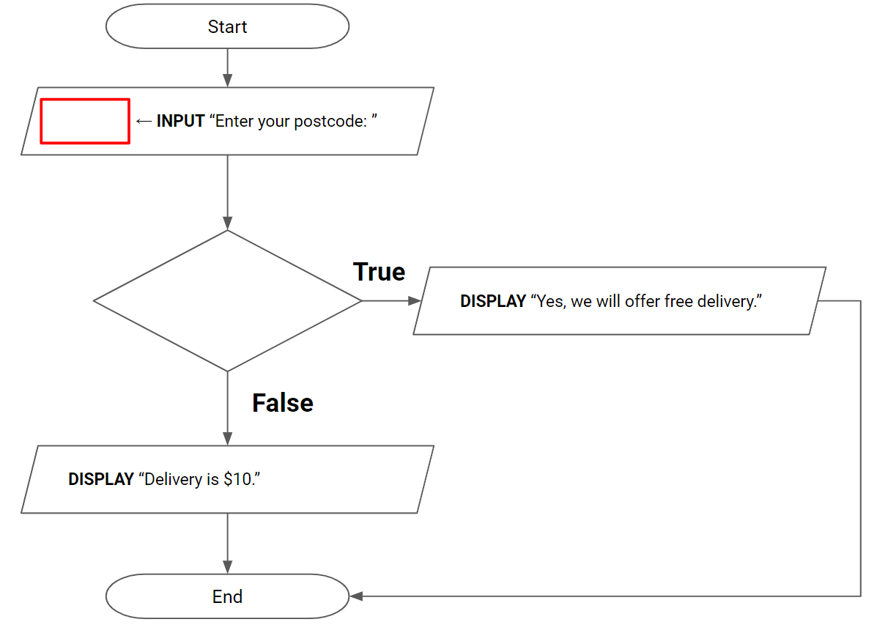

Question 4
I will only buy a used car if it has travelled less than 100000km and if it is less than 5 years old. Complete the flowchart below for an algorithm which asks the seller to type in how far the car has travalled and how old it is, and then displays whether or not I will buy the car.

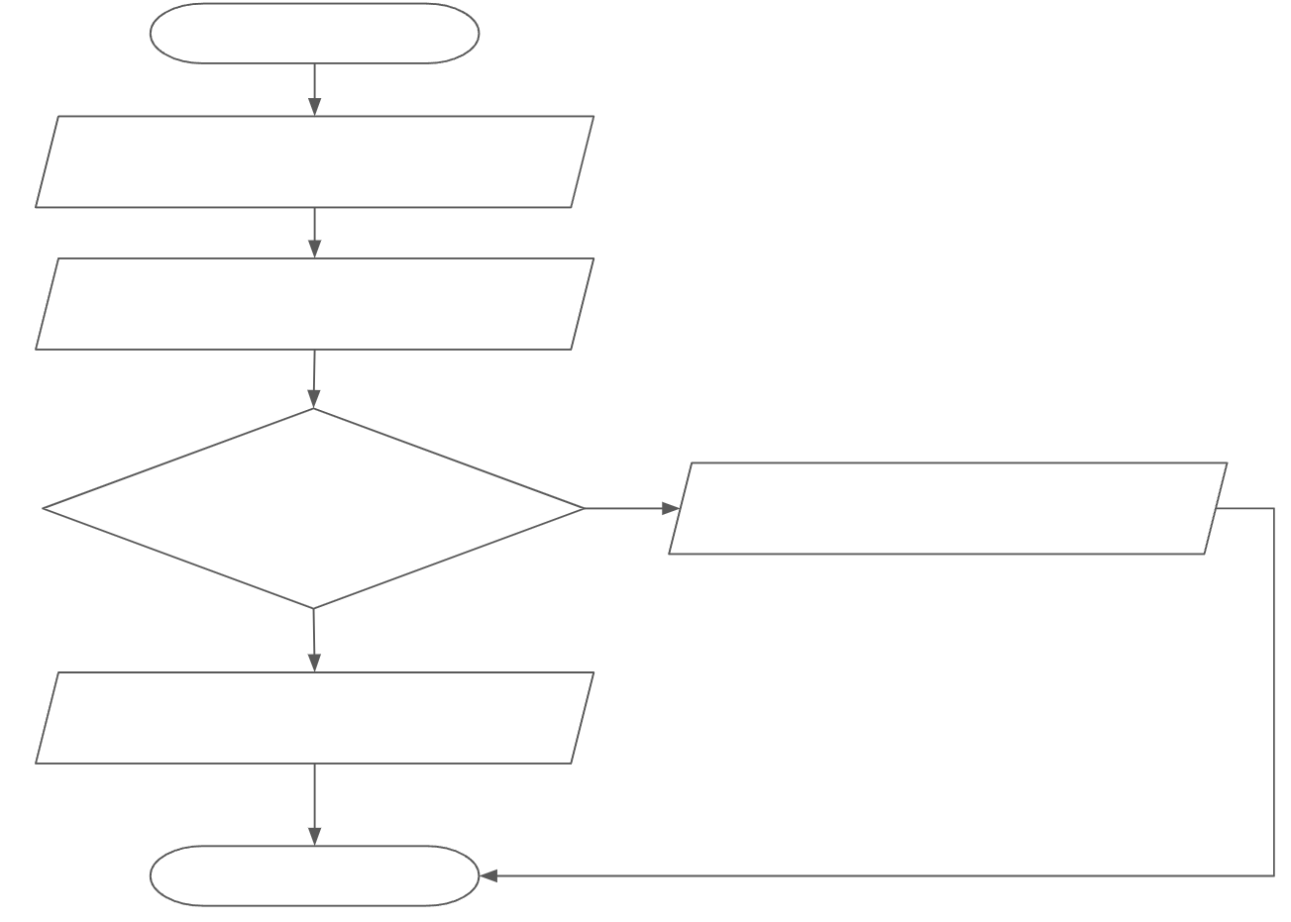

Question 6
A square is a quadrilateral with 4 equal sides and 4 right angles. Draw a flowchart for an algorithm which does the following:
- Tells the user to think of a quadrilateral.
- Ask the user how many equal sides it has.
- Ask the user how many right angles it has.
- Determine whether or not the quadrilateral is a square and display the result to the user.

Question 7
Draw a flowchart for an algorithm which does the following:
- Ask the user how many guests will be attending the party.
- Ask the user how much dinner costs per guest.
- Calculate the total cost of the party.
- If the total cost is between $100 and $200 inclusive, display “The party is going ahead!”
- Otherwise display “Sorry, let’s try again next time.”

Question 8
Consider the flowchart below. Then fill in the table with what you would expect the algorithm to display depending on the given values of the pops and time variables.

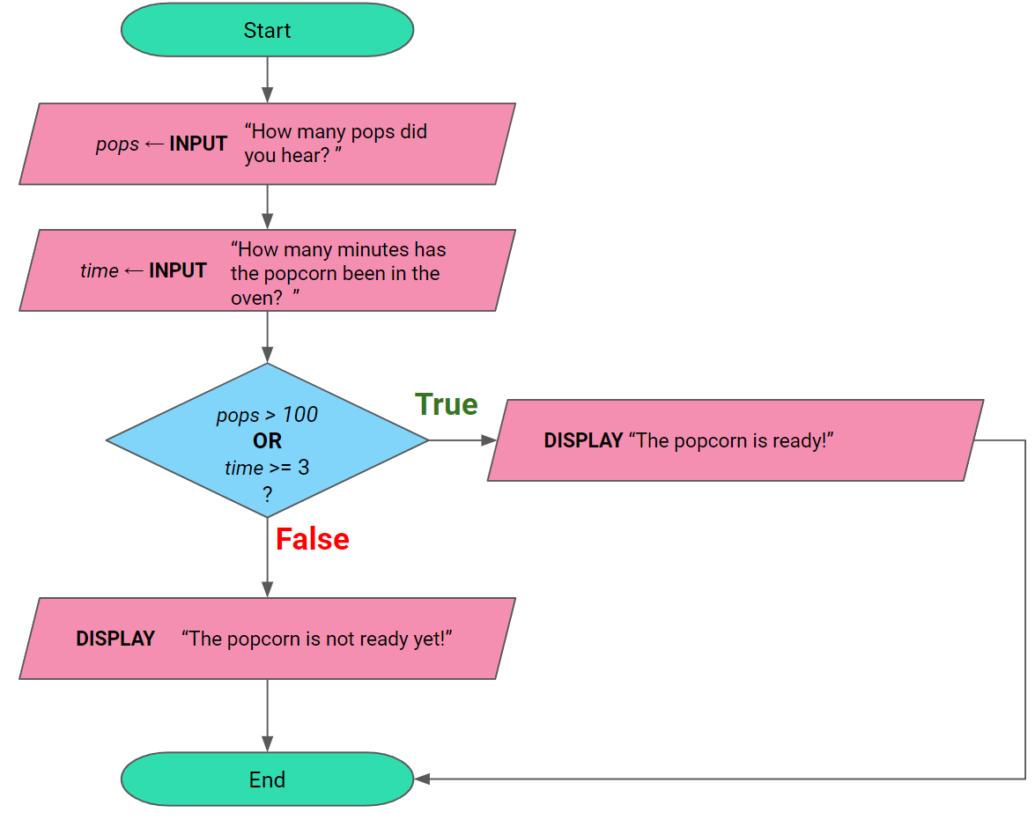

pops | time | What will be displayed?
110 | 4 | The popcorn is ready!
80 | 2 | The popcorn is not ready yet!
80 | 3 | The popcorn is ready!
100 | 2 | The popcorn is not ready yet!
120 | 1 | The popcorn is ready!
60 | 5 | The popcorn is ready!

Question 9
You’ll win the talent show if you get more than 50 student votes or if you get more than 10 teacher votes. Complete condition in the decision box in the flowchart below to represent an algorithm to decide if you win.

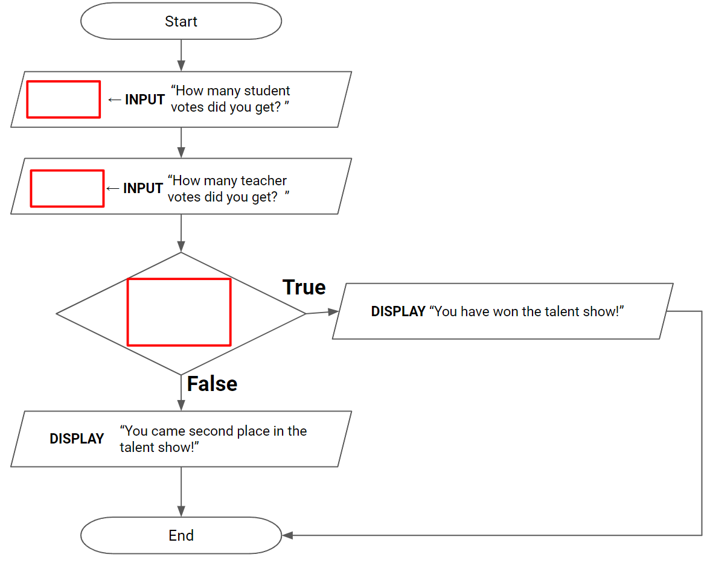

Question 10
A restaurant offers free meals for customers aged over 70 or under 10.
Complete the flowchart below to represent an algorithm which displays whether or not a customer is entitled to a free meal after asking for their age.

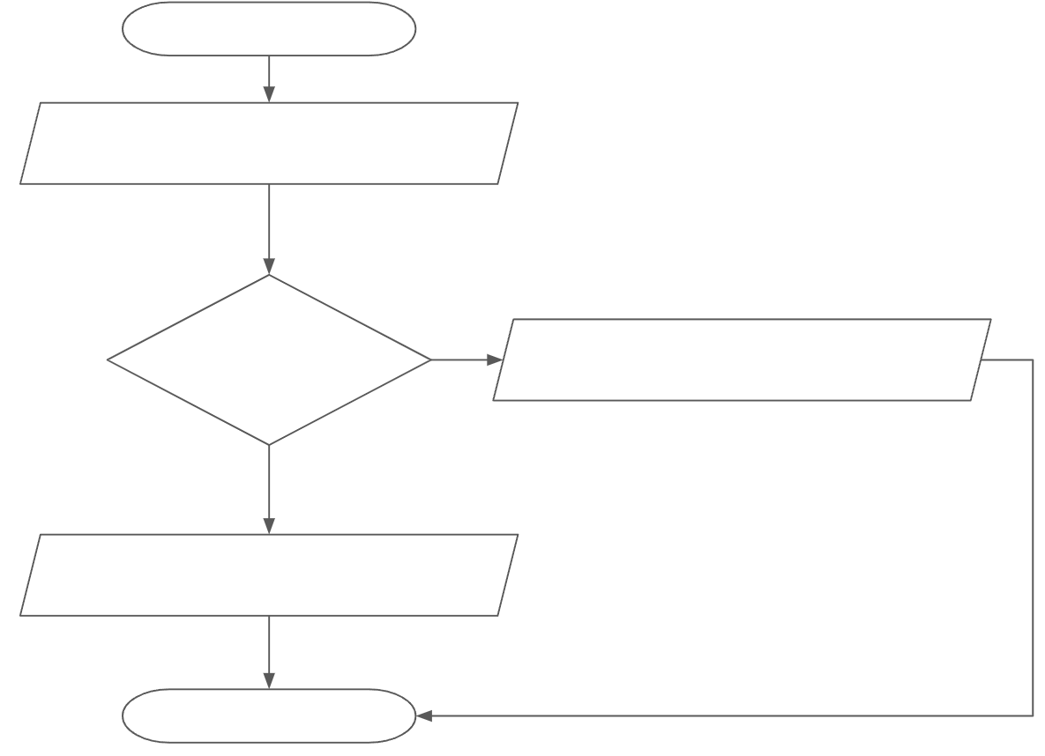

Question 11
A binary digit is either a 0 or 1. Draw a flowchart for an algorithm which asks the user to type in a number and then tells them whether that number is a binary digit or not.

Question 12
A football player will not play the following week if they kicked either less than 10 points (so they can practice!) or if they kicked over 100 points (so they can rest!).

A goal is worth 6 points, and a behind is worth 1 point.

Complete the flowchart below for an algorithm which asks the player to enter the number of goals and behinds they kicked, and then displays whether or not they will play the following week.

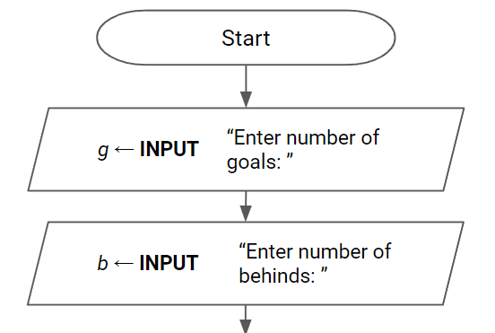

Question 13
An online store will offer free delivery for addresses with postcodes which fall within the ranges below:
- 3200 to 3299
- 3650 to 3699
Complete the flowchart below for an algorithm which asks for the user’s postcode and then displays whether or not they are eligible for free delivery.
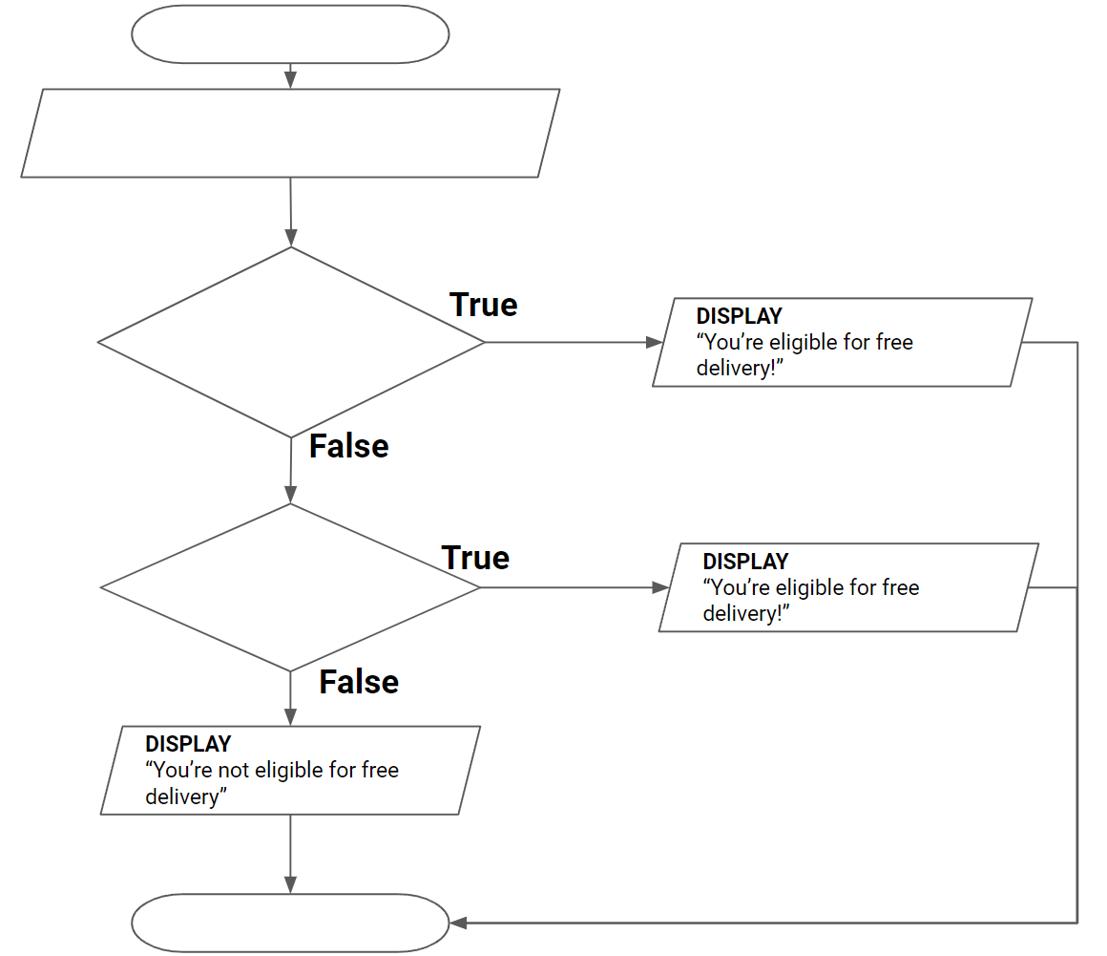

Question 14
Repeat Question 13 but using only 1 (one) decision box.
You may combine compound boolean expressions using parentheses, for example:
( temperature < 10 OR temperature > 100 ) AND ( speed < 20 OR speed > 120 )

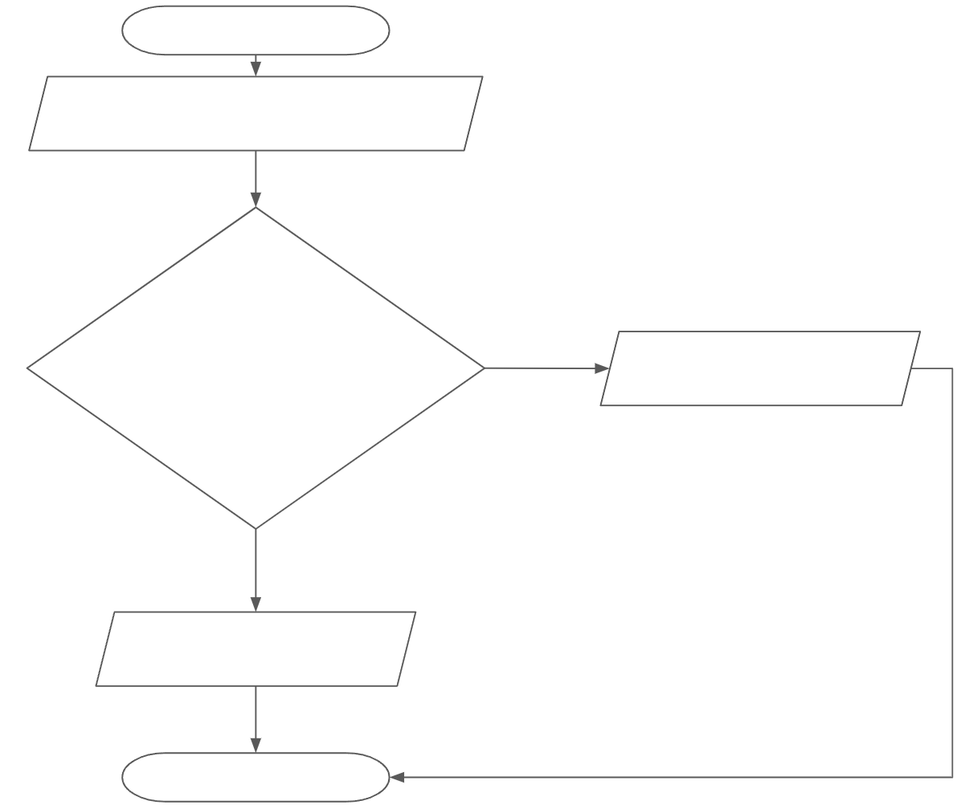

Question 15
For both of the similar triangles below, label all the sides (A, B, C) and angles (a, b, c) according to how they are described in the slides.

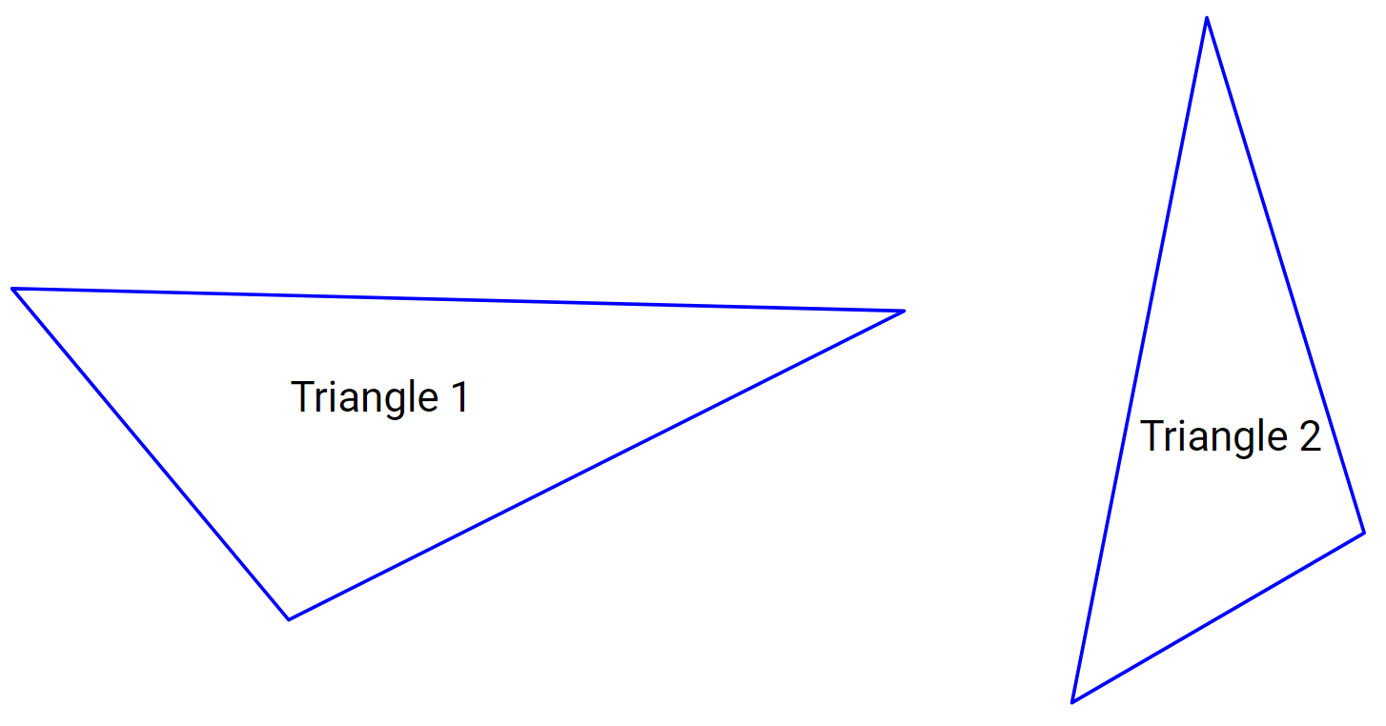

Question 16
Consider the two (2) labeled triangles below.
Complete the flowchart so that it correctly represents an algorithm which identifies whether or not two triangles are congruent using the angle-angle-side rule with the angles and side shown in the diagram.

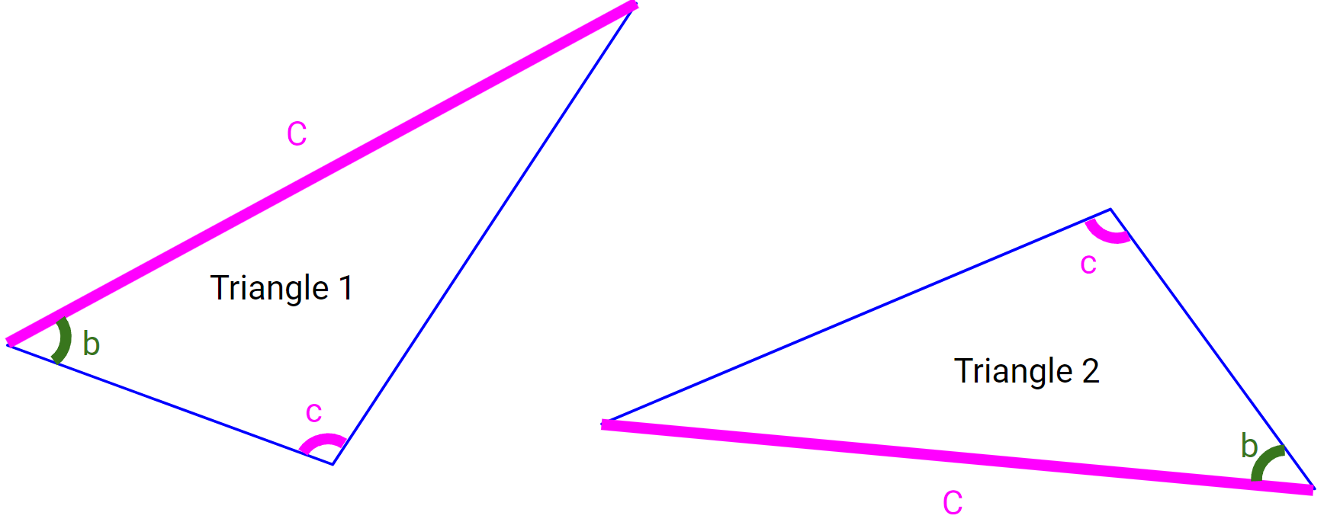

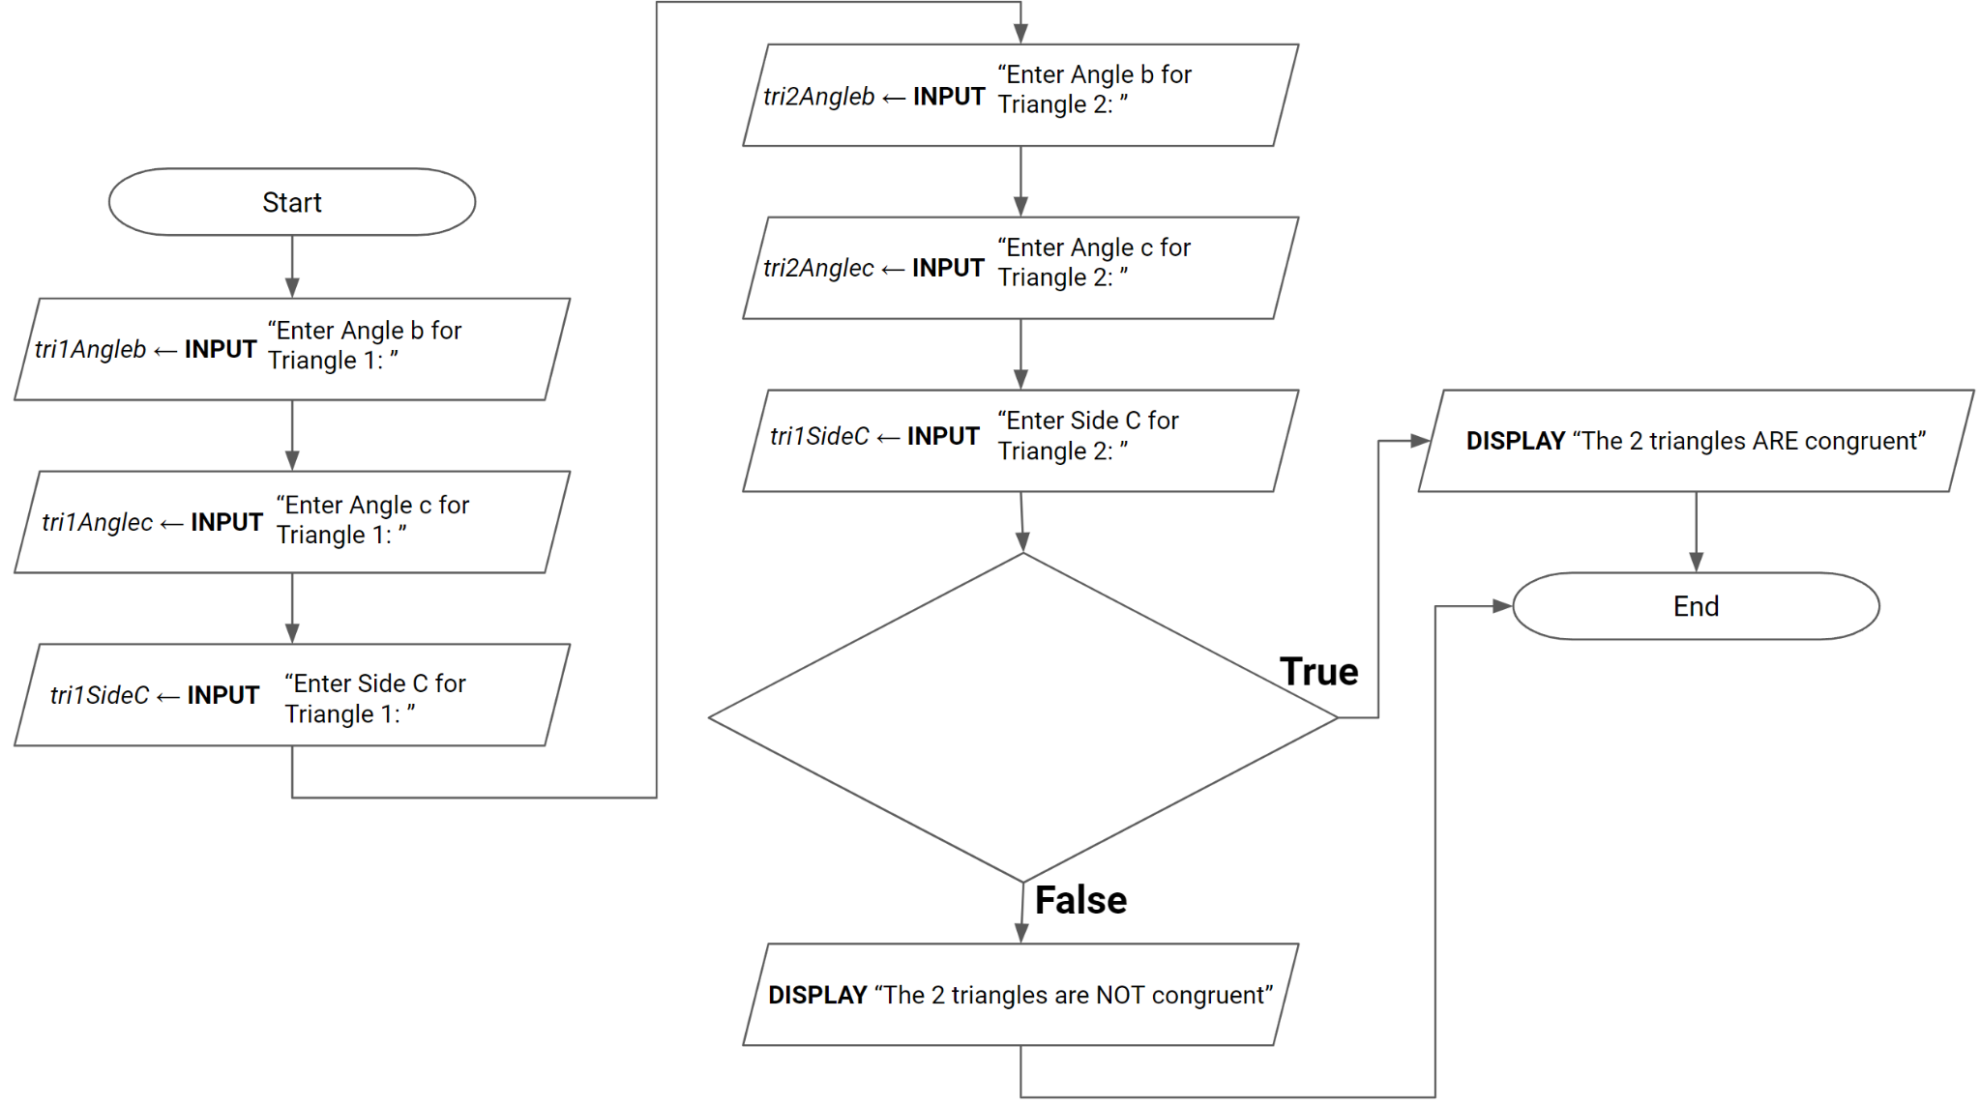

Question 17
Consider the two (2) labeled triangles below.
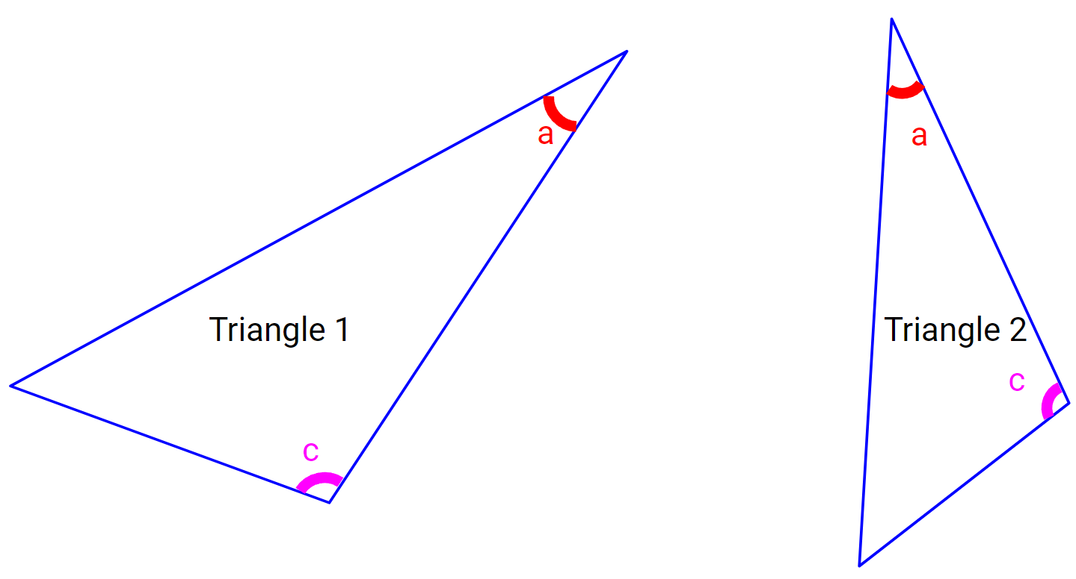
Complete the flowchart below for an algorithm which determines whether two triangles are similar or not by using the angle-angle rule, and displays the result to the user.

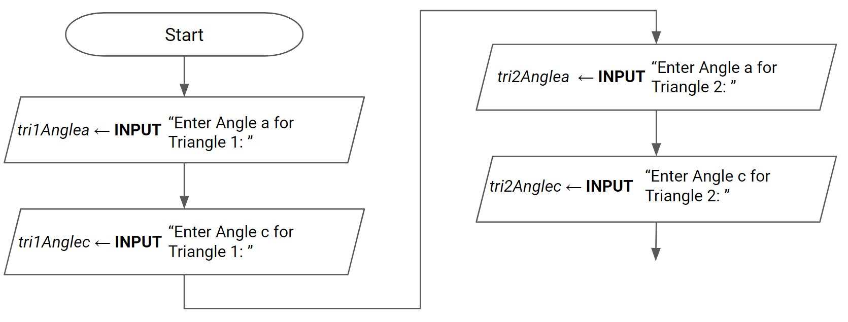

Question 18
Consider the two (2) labeled triangles below.
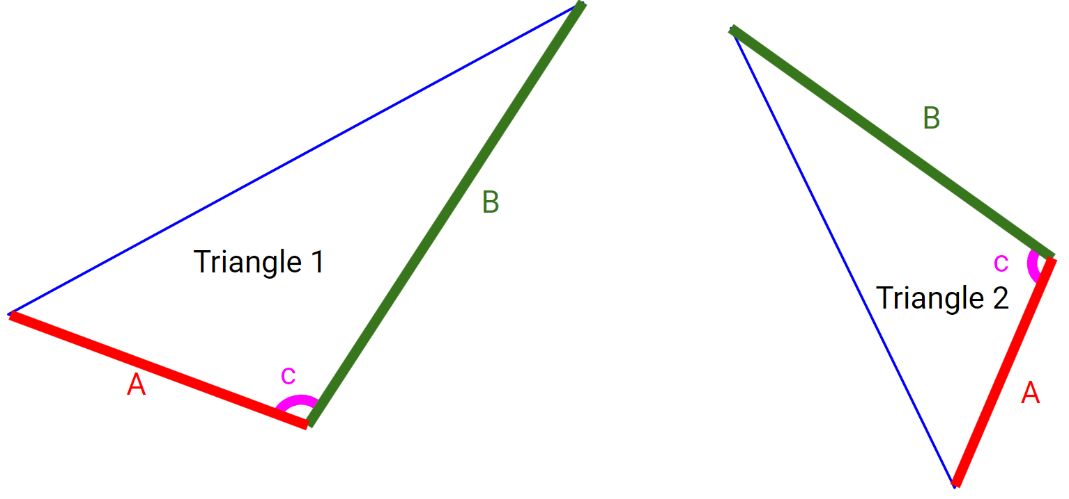
Draw a flowchart for an algorithm which determines does the following:
- Ask the user to enter appropriate sides and angles for triangle 1
- Ask the user to enter appropriate sides and angles for triangle 2
- Determine whether the 2 triangles are similar or not by using the appropriate rule
- Display the result to the user

Question 19
Consider the two (2) labeled triangles below.
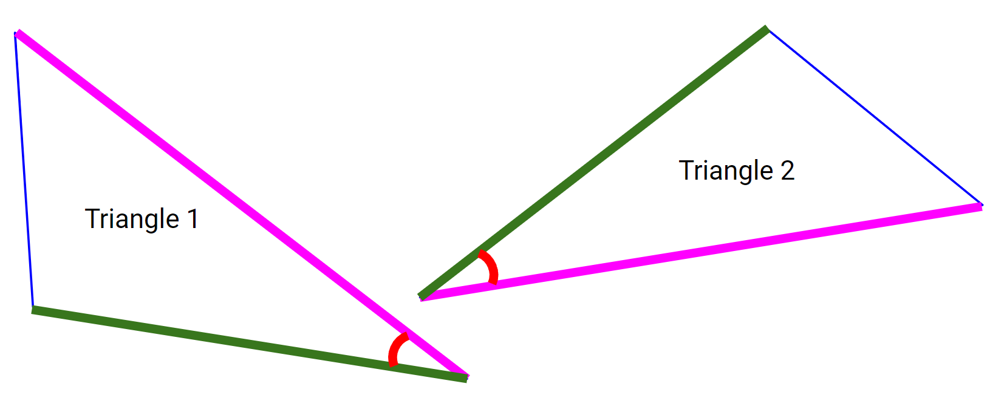
Draw a flowchart for an algorithm which determines whether the 2 triangles are congruent.
- Ask the user to enter the highlighted sides and angles for triangle 1 (please use the naming conventions covered in the slides)
- Ask the user to enter the highlighted sides and angles for triangle 2 (please use the naming conventions covered in the slides)
- Determine whether the 2 triangles are congruent or not by using the appropriate rule
- Display the result to the user

