
02.01 Worksheet: Decisions with Variables
Name | .................................................................................
Class | .................................................................................

Question 1
The flowchart below describes an algorithm which asks the user to type in the number of sides in a polygon. If there are 4 sides, it displays “That’s a quadrilateral”, if not, it displays “That’s not a quadrilateral.”

Complete the flowchart below so that the algorithm displays the correct information after the user enters the number of sides.

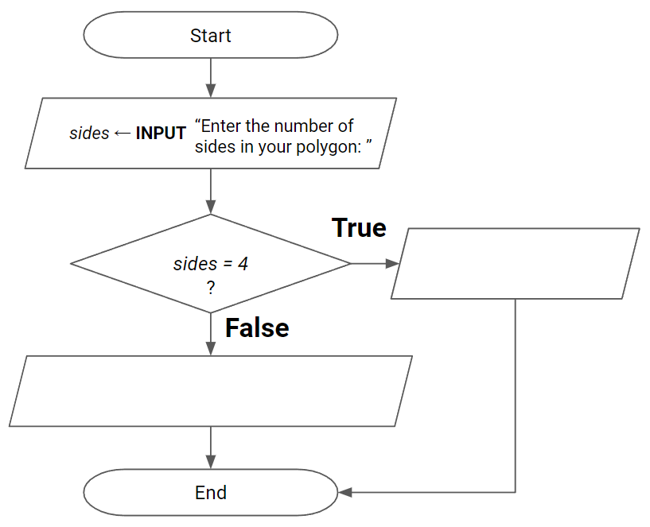

Question 2
When you are 16 years or older, you are able to obtain your learner’s driving permit.
Complete the flowchart below so that the algorithm displays the correct information after the user enters their age.

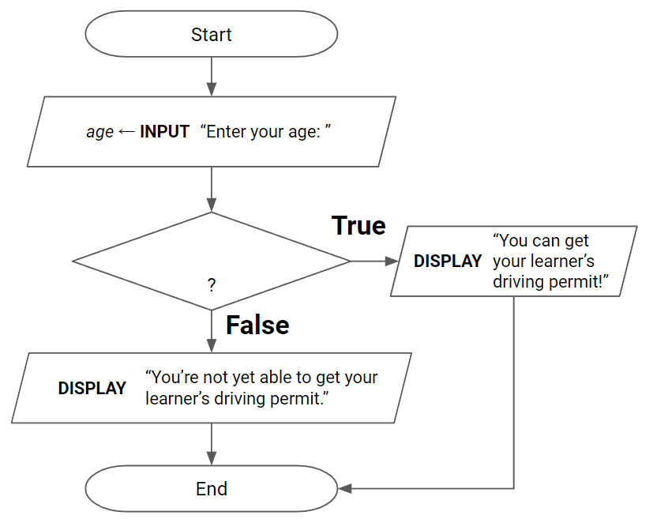

Question 3
The flowchart below represents an algorithm which asks the user to enter an angle value in degrees and then identifies whether it is a right angle or not to the user. Complete the flowchart so that it correctly represents the algorithm.

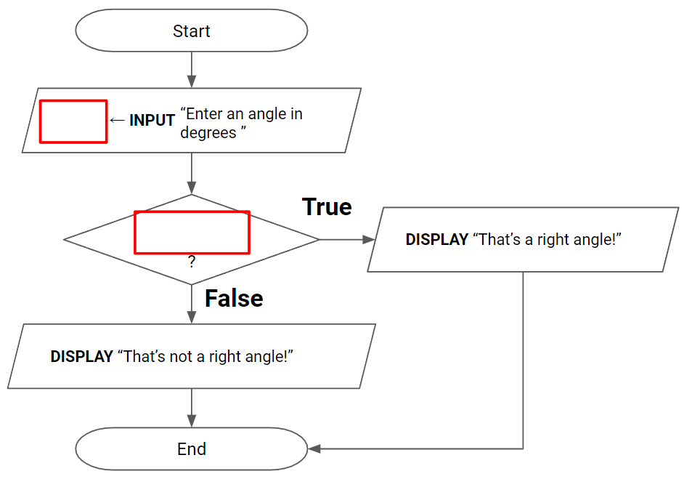

Question 4
Complete the flowchart below for an algorithm which asks the user to type in their score. If it is greater than or equal to 50, display “You passed!” otherwise display “Try again.”

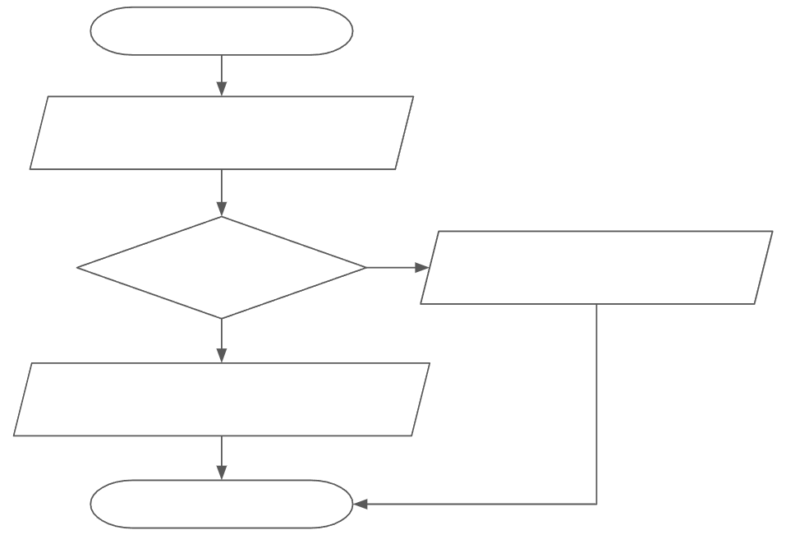

Question 5
Draw a flowchart below for an algorithm which asks the user to type in the number of states and territories in Australia. If the answer is 8, display “Correct!” otherwise display “Incorrect, the answer is 8.”

Question 6
Draw a flowchart below for an algorithm which does the following:
- Ask the user to type in an angle in degrees
- Ask the user to type in another angle in degrees
- If they add up to 90 degrees, display “Those angles are complementary”
- If they do not add up to 90 degrees, display “Those angles are not complementary.”

Question 7
The flowchart below represents an algorithm which asks the user to enter the number of pairs of parallel sides there are in a 4-sided polygon. It then identifies whether the shape is a trapezium (1 pair of parallel sides), parallelogram (2 pairs of parallel sides) or a quadrilateral (no pairs of parallel sides). Complete the flowchart so that it correctly represents the algorithm.

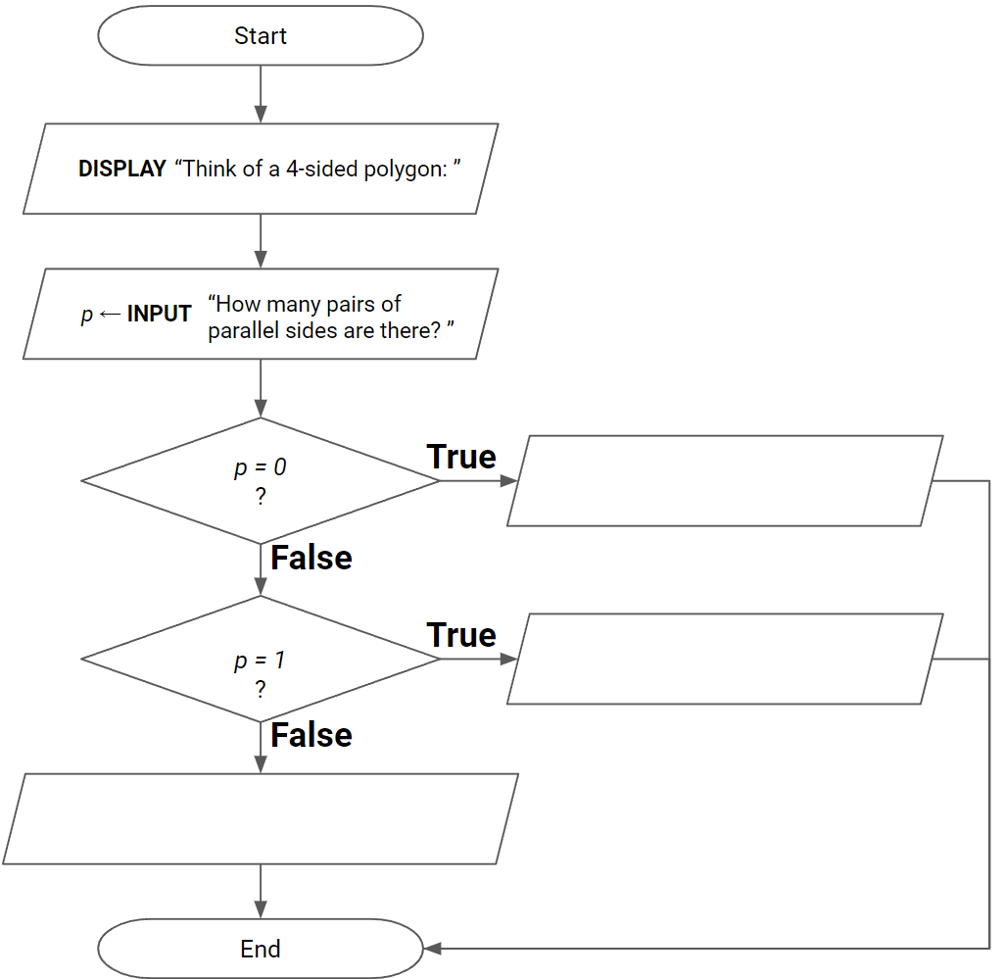

Question 8
The flowchart below represents an algorithm which asks the user to enter the value of an angle and identifies whether it is an acute angle (less than 90 degrees), a right angle (exactly 90 degrees) or greater than a right angle. Complete the flowchart so that it correctly represents the algorithm.

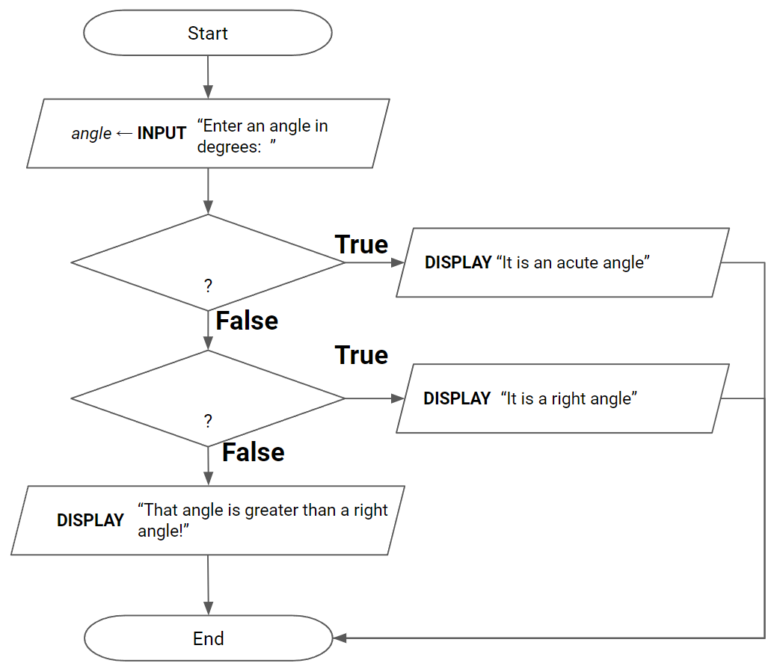

Question 9
Complete the flowchart below for an algorithm which asks the user to type in their height in centimetres. If it is less than 155, display “I’m taller than you!”, if it is exactly 155, display “You’re exactly the same height as me!”, if it is greater than 155, display “You’re taller than me!”

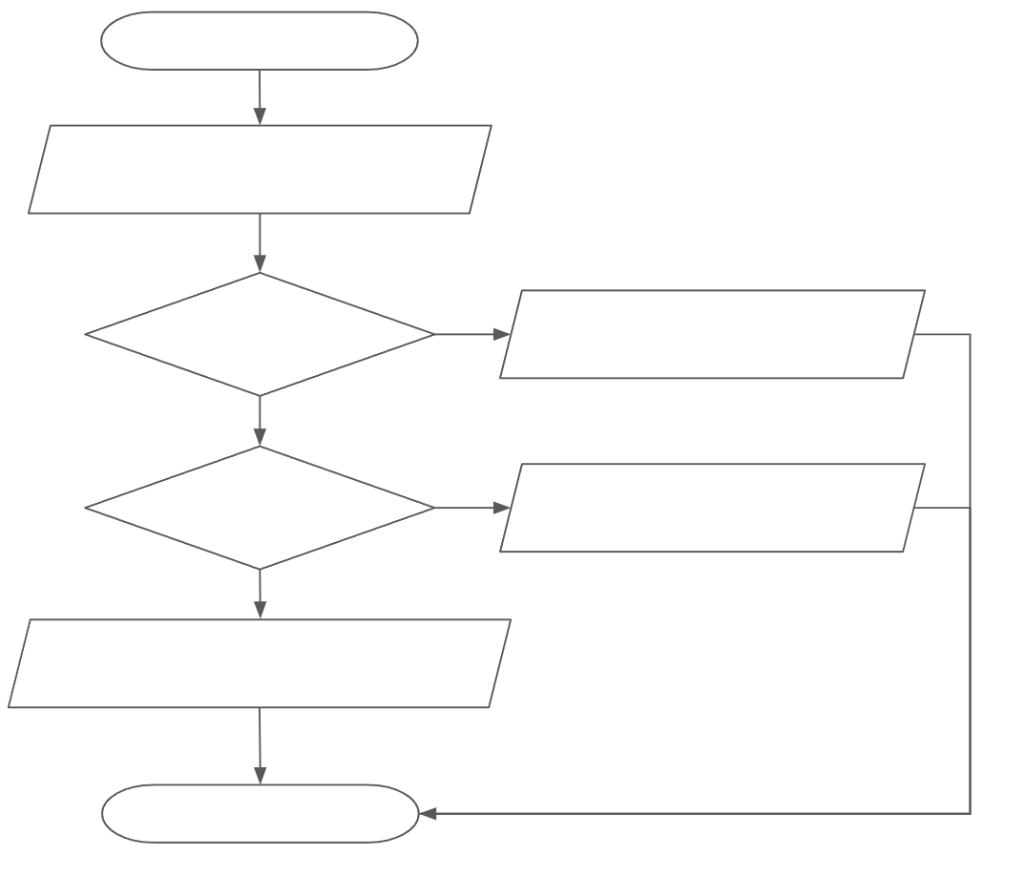

Question 10
Draw a flowchart below for an algorithm which does the following:
- Instructs the user to think of a quadrilateral, pentagon or hexagon
- Asks the user to type in the number of sides in their shape
- Displays whether their shape is a quadrilateral, pentagon or hexagon

Question 11
Draw a flowchart below for an algorithm which does the following:
- Asks the user to type in their score on a test out of 100
- Displays whether they achieved a distinction (greater or equal to 80), a pass (greater than or equal to 50 and less than 80), or did not pass (less than 50)

Question 11
Complete the flowchart below for an algorithm which does the following:
- Asks the user to type in their age
- If the age is greater than or equal to 18, display that they are eligible to vote
- Otherwise calculate how many more years left they need to wait before they can vote and display this to the user
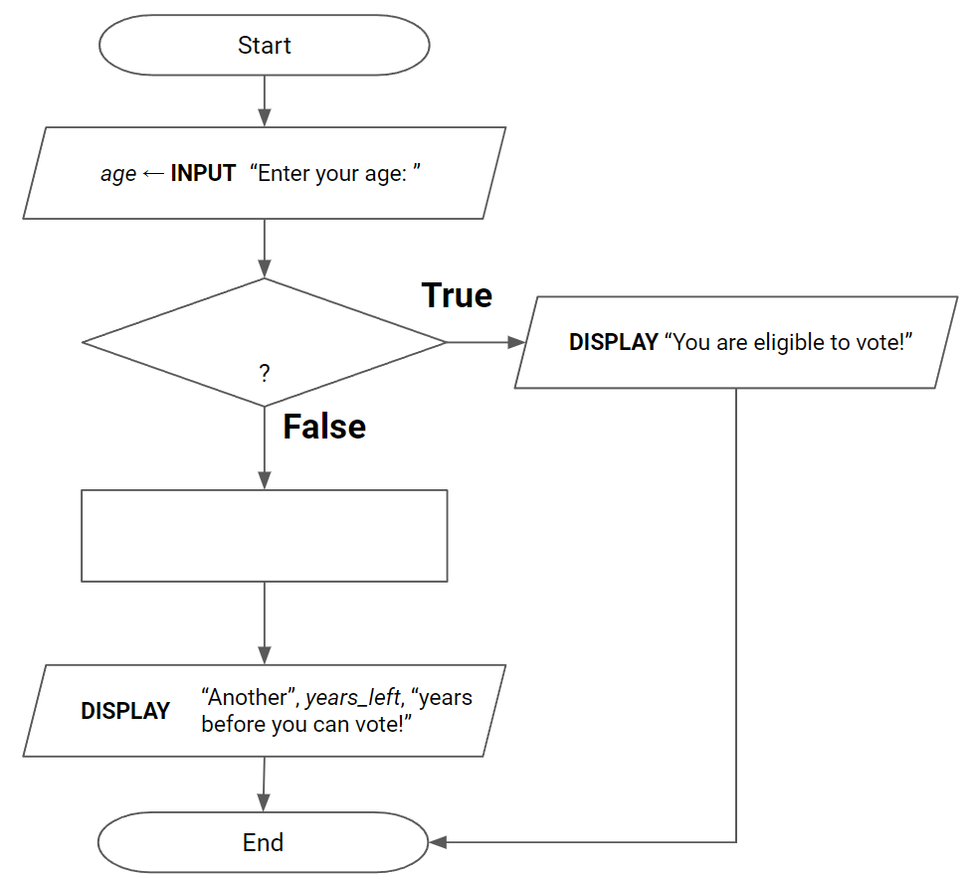

Question 12
Complete the flowchart below for an algorithm which does the following:
- Asks the user to type in the radius of a planet in kilometres
- Calculate the circumference of the planet in kilometres
- If the circumference is greater than 40785 km, display “That planet is larger than Earth!”
- If the circumference is less than 40785 km, display “That planet is smaller than Earth!”
- If the circumference is exactly 40785 km, display “That planet is Earth!”

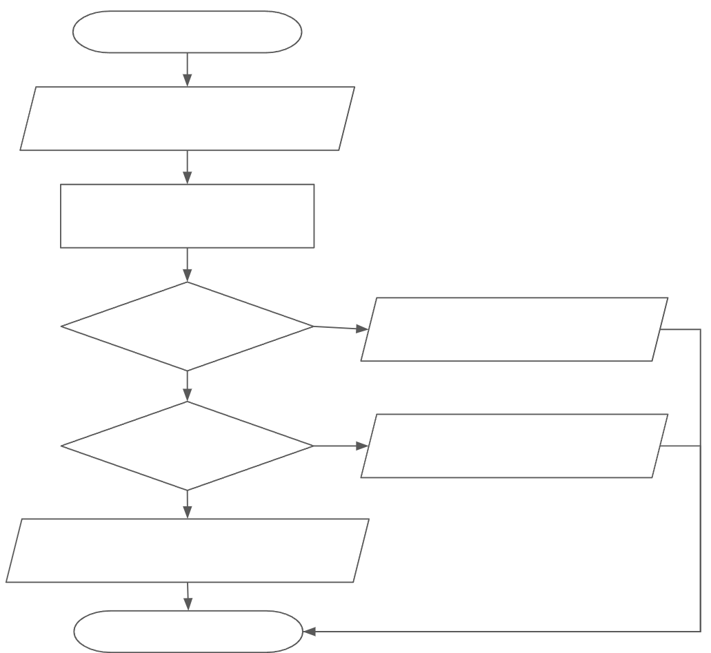

Question 13
Complete the flowchart below for an algorithm which does the following:
- Ask the user to type in their height in centimeters
- Convert the height into feet
- If the height is greater than 6 feet, display “You’re taller than 6 feet.”
- If the height is equal to 6 feet, display “You are exactly 6 feet tall.”
- If the height is less than 6 feet, display “You are less than 6 feet tall.”

Question 14
Complete the flowchart below for an algorithm which does the following:
- Ask the user to type in their marks on a test
- Ask the user to type in the maximum number of marks on the test
- Calculates the percentage score
- If the percentage score is greater than or equal to 90, display “You received a high distinction.”
- Otherwise, if the score is greater than or equal to 80, display “You received a distinction.”
- Otherwise, if the score is greater than or equal to 50, display “You passed.”
- Otherwise display “You did not pass.”

Question 15
A store has a promotion: buy 2 pairs of shoes, get the cheaper pair for free.

Complete the flowchart below to represent an algorithm which asks the customer to type in the price for each of the 2 pairs of shoes, then displays the amount they need to pay.

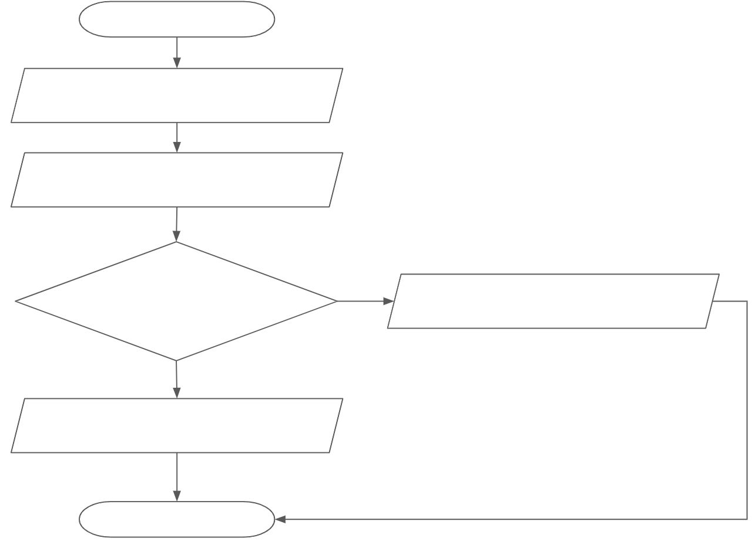

Question 16 - Extension
You’d like to complete a flowchart which converts 24 hour time into 12 hour am/pm time.
The flowchart represents an algorithm which will ask the user to type in the hour in 24-hour time (a value between 0 - 23) and the minute in the hour (a value between 0 - 59).
It will then convert the 24 hour time into 12 hour am/pm time and display it. (examples below)
User enters this in 24 hour time | Algorithm display this in 12-hour am/pm time
Hour: 0  Minute: 34 | The current time is: 12:34 AM
Hour: 8  Minute: 13 | The current time is: 8:13 AM
Hour: 12  Minute: 49 | The current time is: 12:49 PM
Hour: 20  Minute: 25 | The current time is: 8:25 PM



