
01.01 Worksheet: Variables in Flowcharts
Name | .................................................................................
Class | .................................................................................

Question 1
Look at the following variable names and identify whether or not they are valid names:

Variable Name | Valid or Invalid Name?
length
2ndAngle
weight of car
num_apples
dollars2
ObtuseAngle
queen!hearts
x
this_variable_2_IS_notValid

Write down 2 examples of valid variable names not shown above:

Write down 2 examples of invalid variable names not shown above:

Question 2
Answer the following questions for the flowchart below:
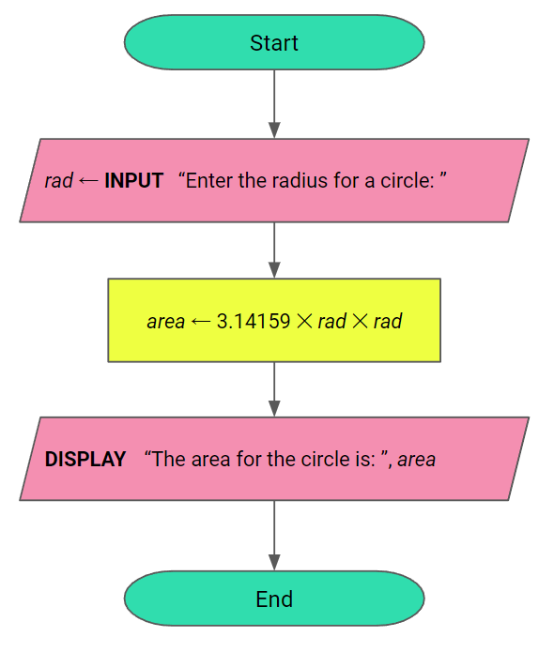
Identify the function(s) in the flowchart:

Identify the variables(s) in the flowchart:

Write down what you think this algorithm is doing:

Question 3
Answer the following questions for the flowchart below:

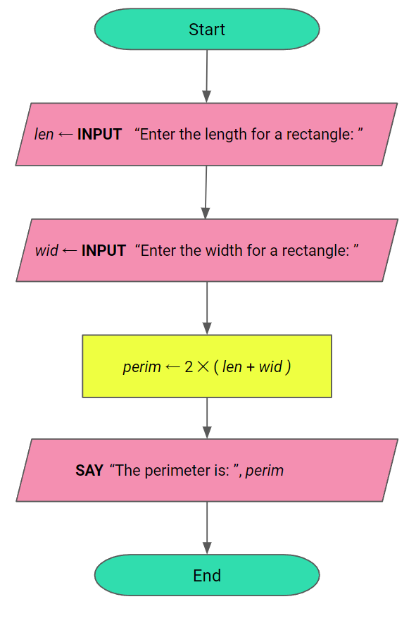

Identify the function(s) in the flowchart:

Identify the variables(s) in the flowchart:

Write down what you think this algorithm is doing:

Question 4
The flowchart for the algorithm below does the following:
- Asks the user to type in the diameter for a circle
- Calculates the circumference of a circle with that diameter
- Displays the value of the circumference to the user.

Fill in the blanks in the flowchart so that algorithm works correctly.
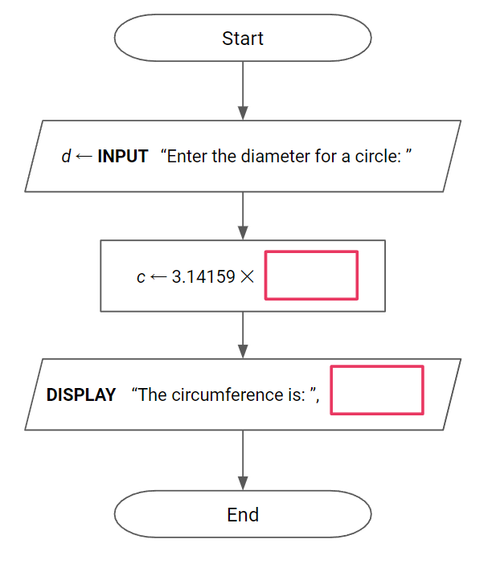

Question 5
The flowchart for the algorithm below does the following:
- Asks the user to type in the length of a square
- Calculates the perimeter of a square with that length
- Displays the value of the perimeter to the user.

Fill in the blanks in the flowchart so that algorithm works correctly.
Note: you may use your own variable names provided they are in a valid format
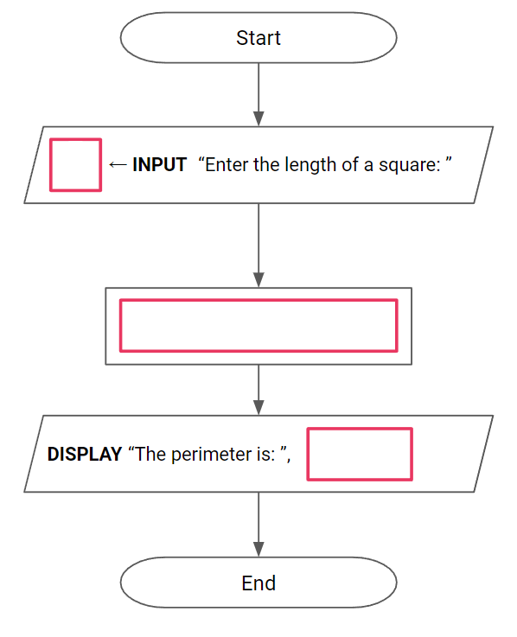

Question 6
The flowchart for the algorithm below asks the user to type in the length, width and height of a cuboid, calculates the volume for the cuboid and displays the volume back to the user.

Fill in the blanks in the flowchart so that algorithm works correctly.
Note: you may use your own variable names provided they are in a valid format

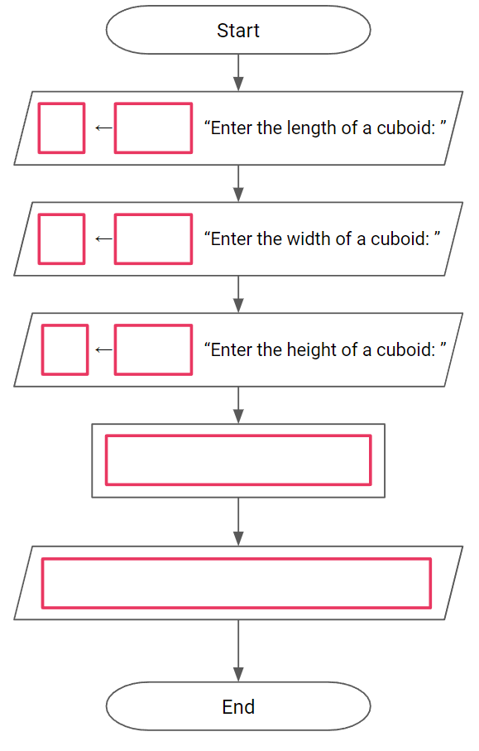

Question 7
The flowchart for the algorithm below asks the user to type in the height, base1 and base2 of a trapezium, calculates the area for the trapezium and displays the area back to the user.

Fill in the blanks in the flowchart so that algorithm works correctly.
Note: you may use your own variable names provided they are in a valid format

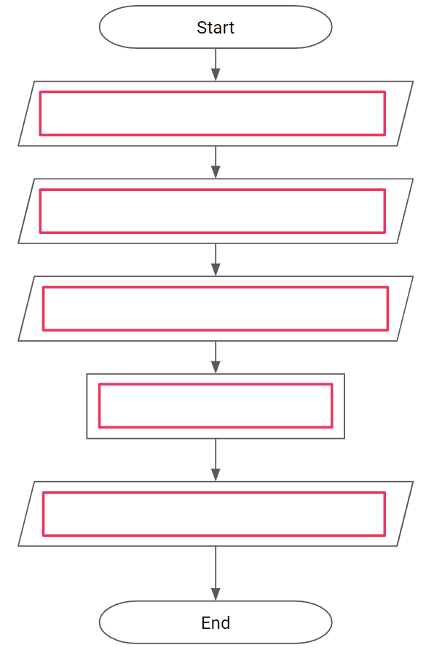

Question 8
Draw a flowchart for an algorithm which asks the user to type in diameter for a circle, then calculate the area for the circle and displays the area back to the user.

Question 9
Draw a flowchart for an algorithm which asks the user to type in an acute angle. It then calculates the complementary angle and displays the complementary angle back to the user.

Question 10
Draw a flowchart for an algorithm which asks you to type in your mark for a test and what the total marks were. It then calculates the percentage you scored and displays the percentage.

Question 11
Draw a flowchart for an algorithm which asks the user to type in the appropriate dimensions for a triangular prism, calculates the volume for the triangular prism and displays the result.

