
02.01 Worksheet: Drawing Flowcharts
Name | .................................................................................
Class | .................................................................................

Question 1
Draw arrows to match up the following flowchart shapes with their correct names.

 |  | Decision
 |  | Start or End
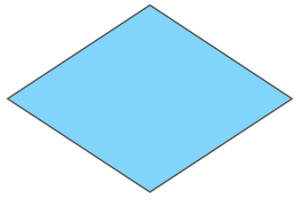 |  | Input or Output

Question 2
We would like to draw a flowchart for an algorithm which will:
- Ask you to think of your birthday date.
- If it is today, display “Happy Birthday for today!”
- If it is not today, display “It’ll be here before you know it!”

Complete the flowchart below so that the algorithm is complete and correct.

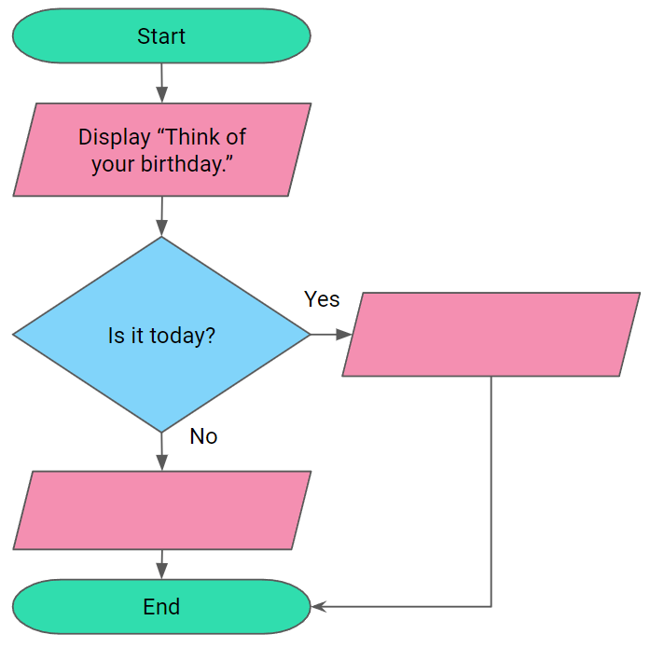

Question 3
We would like to draw a flowchart for an algorithm which will determine whether a number that someone thinks of is divisible by 2.
- If the number is even, the algorithm should display “It is divisible by 2!”
- If the number is not even, the algorithm should display “It is not divisible by 2!”

Complete the flowchart below so that the algorithm is correct.

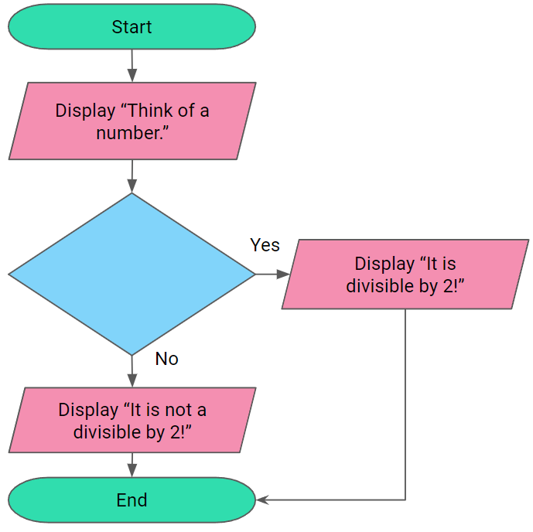

Question 4
We would like to draw a flowchart for the following algorithm:
- Ask the user to think of their age.
- If the age is 11, the algorithm should display “That’s the same age as me!”
- If the age is not 11, the algorithm should display “Cool! I am 11 years old.”

Fill in the shapes in the flowchart below to represent the above algorithm.
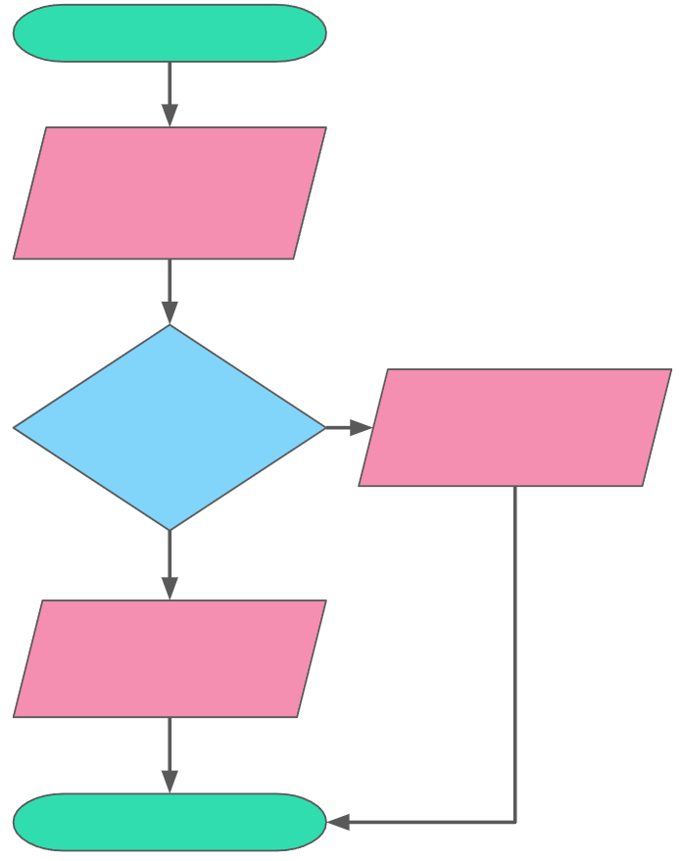

Question 5
Draw a flowchart for the algorithm below:
- Ask the user to think of an animal with stripes.
- If the animal is a zebra, display “I was thinking of a zebra too!”.
- If the animal is not a zebra, display “Nice! I was thinking of a zebra though!”.

Question 6
Draw a flowchart for the algorithm below:
- Ask the user to think of a number.
- Using the divisibility rule for 5, correctly display “It is divisible by 5!” or “It is not divisible by 5!”

