
(Make your own copy by clicking the File menu, and then Make a copy)

Assignment - A Simple Text Adventure Game

Name | .................................................................................
Class | .................................................................................

Recommended working duration: 2 weeks
Your task is to program a simple text adventure game similar to these three examples:

- City of Gold
- Warehouse Quest
- Your Spirit Animal

Your game needs to contain at least five scenes with at least two choices in each scene. Example scenes could be rooms, locations, battles, situations, questions, and so on.
More than one choice from different scenes can lead to the same scene.
You must be able to finish the game!
Using colours in your game is encouraged. You could also optionally draw graphics, clear the screen, and use other visual ideas to make your game appealing.
Please see the above two games as examples. There is also some starting template code, and an accompanying video guide that you might find helpful.
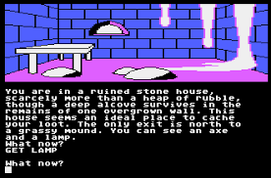
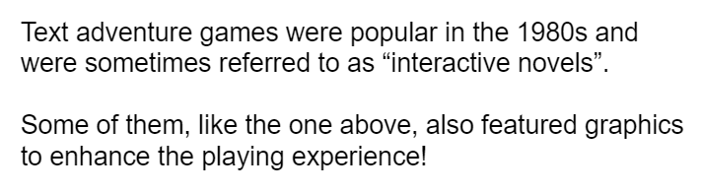

Marking Rubric

 | Exceeding (3) |  | Achieved (2) | Developing (1) | Not Shown (0)
Organisation of Code | Code is clearly structured with comments and context provided for reader |  | Comments are included in code | Code uses white space for readability | Code is very difficult to read
 | Exceeding (3) | Achieved (3) | Consolidating (2) | Developing (1) | Not Shown (0)
Quality of Code | Code incorporates IF statements and loops by utilising labels and goto statements | IF statements are used correctly | Code includes a variety of functions | Code runs without errors | The code does not run
 | Exceeding (3) |  | Achieved (2) | Developing (1) | Not Shown (0)
Creativity | Descriptive language is effective at building excitement / suspense |  | The game presents an original premise | Game is straight forward | Not shown
 | Exceeding (3) |  | Achieved (2) | Developing (1) | Not Shown (0)
Visual Appeal | Visual elements are used effectively to add excitement to the user experience |  | Visual elements are successfully incorporated into the game | Visual elements (colour/ASCII) are attempted | The game consists of all plain white text
 | Exceeding (3) |  |  | Achieved (2) | Not Shown (0)
Clarity of Instructions | Instructions facilitate a smooth user experience |  |  | Game includes menu or key words to direct user | No instructions provided to direct user
 | Exceeding (3) |  | Achieved (2) | Developing (1) | Not Shown (0)
Game Complexity | Game enables user to achieve multiple endings via different paths encouraging multiple play throughs |  | Game requires interaction from the user to reach a successful conclusion | The game is linear without choices affecting the ending | The game does not run
 | Exceeding (3) |  |  | Developing (1) | Not Shown (0)
State Diagram Design | A complete state diagram with all locations and choices is provided. |  |  | A state diagram with some missing components is provided. | No state diagram is provided.

