Worksheet 05.01 - Flowcharts
Name | .................................................................................
Class | .................................................................................

Question 1
Examine the flowchart below:
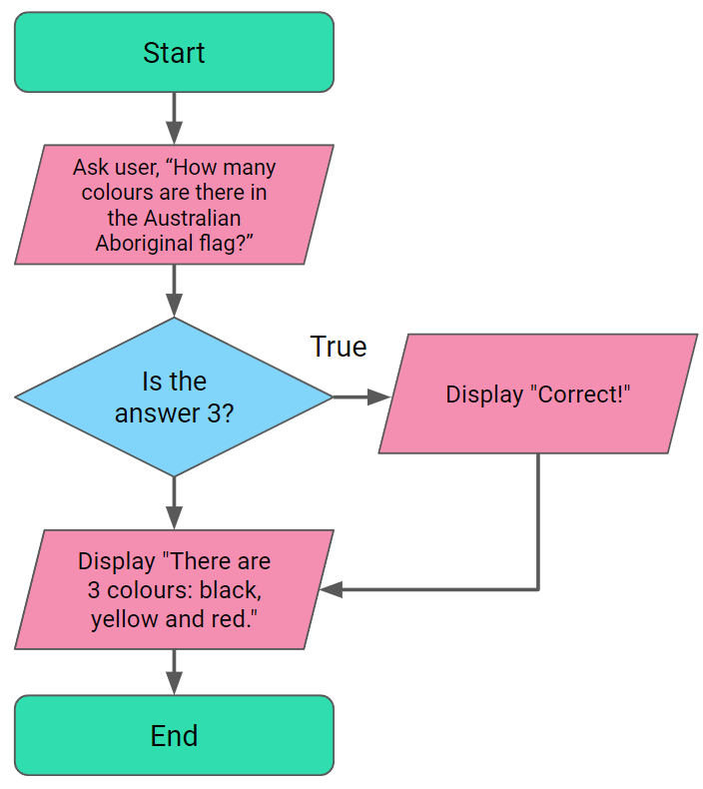

Complete the Python code below to represent the flowchart:
colours = input("How many colours are there in the Aboriginal Australian flag?")

if ________________________________

print ________________________________

print ________________________________

Now complete Coding Task 05.012 - Colours in the Flag on the Lesson Web Page.

Question 2
Examine the flowchart below:
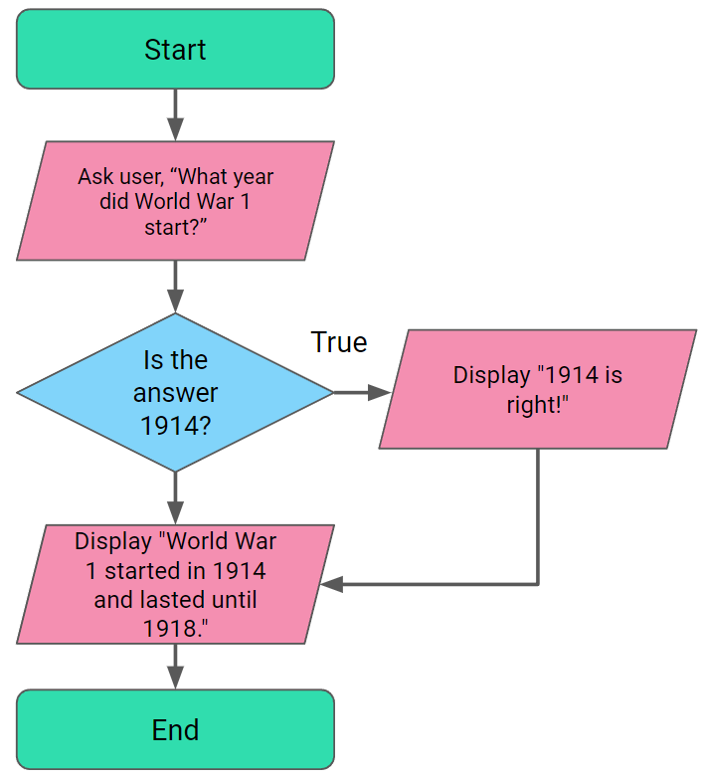

Write the Python code to represent the flowchart:

Now complete Coding Task 05.02 - A History Quiz on the Lesson Web Page.

Question 3
It’s now your turn to design your own question and answer quiz!

In the space below, draw a flowchart to represent your own question and answer quiz:

Write the Python code to represent the flowchart:

Now complete Coding Task 05.03 - Your Own Quiz on the Lesson Web Page.

