

Assignment: AI to Solve World Problems!
Name: | .................................... | Class: | .....................................
Introduction
It’s now your turn to apply the knowledge and skills you have developed in this course to design and build a prototype AI classifier to address a problem in the real world!



You’ll be completing the following steps:
- choose a UN Sustainable Development goal as your focus,
- think of how an AI classifier can address this goal,
- design how to collect training and testing data,
- build the classifier,
- evaluate its performance,
- iterate and improve its performance, and then
- report on your findings in a poster

Please note that the goal of this assignment is not to build the perfect classifier. It is aimed at thoroughly and comprehensively going through the design and evaluation process for building an AI solution, and provide detailed and clear evidence along the way.

Step 1: Choosing a Sustainable Development Goal
Visit The U.N. Sustainable Development Goals site (https://sdgs.un.org/goals), read through each of the goals, and choose one to build a prototype AI classifier solution for.
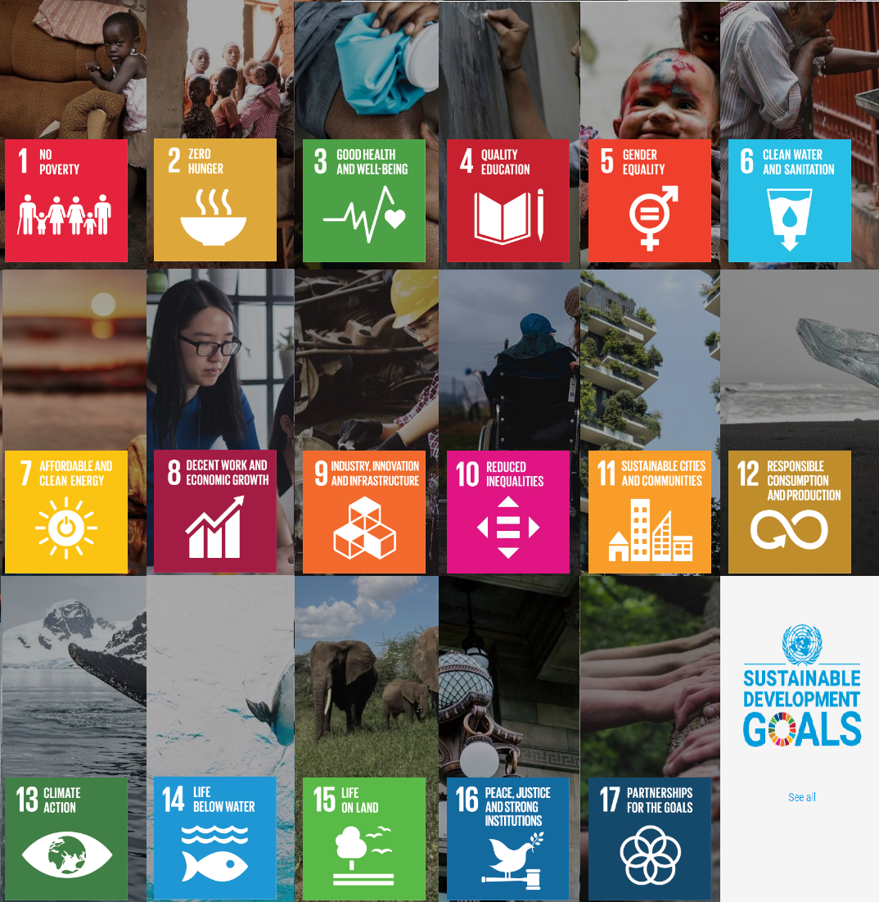
The Sustainable Development Goal which we would like to focus on is:

Step 2: Review Skills and Brainstorming Solutions
In order to help address the following SDG:

I will be building the following type of classifier (image, audio, pose):

Which will do the following:

For the following people to use:

For the purposes of:

Step 3: Collecting Training and Testing Data
The type of data I will be collecting / generating (e.g. images, poses, audio) is:

The classes I will be predicting are:

How I will collect or generate the data (e.g. looking for images on the internet based on the search keywords ‘cats’, posing in front of the webcam in the Teachable Machines site in a ‘Y’ pose, recording sounds of cats meowing):

How will I avoid introducing sampling bias into my data (e.g. using images of cats of different colours, sizes, breeds, doing ‘Y’ poses in at different locations and with people of all genders and sizes and ages, recording sounds of cats meowing in my backyard, using different phones, and in the park and around my neighbourhood):

Extend and fill in the below table to record how many samples for each class you will be using for training and testing:

Class Name | Number of training samples | Number of testing samples
Step 4: Use Teachable Machines to Produce a Classifier
How did you go in Step 3? Did you think you could successfully build a classifier prototype (with some help from your teacher), or was it too complex, or was it perhaps too simple?

In this step you have a chance to revisit Steps 1 - 3 and change your goal and/or solution based on how confident you are with collecting data for, and building a classifier. The aim is to choose a goal and solution which you can successfully design and prototype a classifier.

Please feel free to repeat Steps 1 - 3 as much as needed until you arrive at an idea which you think you can actually build a prototype classifier in Teachable Machine.

It is okay for the classifier to be simple – as long as it addresses the SDG and the problem you would like to solve!

Step 5: Evaluating your Classifier
- Produce a shaded confusion matrix
- For each of your classes:
  - True Positive Rate
  - True Negative Rate
  - False Positive Rate
  - False Negative Rate
Step 6: Iterating and Improving Your Classifier
Based on your results from Step 6, go through at least 2 more rounds of training and testing with more data to see if you can improve the statistics. Record your results after each round.

Step 7: Prepare a Poster
Prepare and deliver a 3 slide presentation where you discuss your final details for Steps 2 and 3, and where you demonstrate your program running to the class. If your program doesn’t fully work, that’s okay as well, just demonstrate what you tried and where you might have gotten stuck.
Marking Rubric (Total: 16 marks)
SDG Goal and Idea  /1 | Completed (1) |  |  | Not Shown (0)
SDG Goal and Idea  /1 | A SDG goal was specified in Step 1. |  |  | No SDG goal was specified.
Description of Idea  /3 | Excelled (3) | Completed (2) | Attempted (1) | Not Shown (0)
Description of Idea  /3 | Step 2 was completed and demonstrated innovative, thoughtful, detailed and accurate answers to the questions with correct references to classifier, machine learning and AI concepts. | Step 2 was completed and demonstrated some thoughtful, detailed and accurate answers to the questions with references to classifier, machine learning and AI concepts. | Parts of Step 2 were completed and demonstrated some thoughtful answers to the questions with some references to classifier, machine learning and AI concepts. | Step 2 was not completed
Design of data collection  /3 | Excelled (3) | Completed (2) | Attempted (1) | Not Shown (0)
Design of data collection  /3 | In Step 3, a detailed and achievable outline of the data collection strategy was provided with clear consideration given to reducing sampling bias. | In Step 3, a detailed outline of the data collection strategy was provided with some consideration given to reducing sampling bias. | In Step 3, an outline of the data collection strategy was provided. Minimal or no consideration was given to reducing sampling bias. | Step 3 was not completed.
Classifier Prototype  /2 | Excelled (3) | Completed (2) | Attempted (1) | Not Shown (0)
Classifier Prototype  /2 | The prototype classifier demonstrated acceptable results. Sufficient training and testing iterations were demonstrated. | The prototype classifier demonstrated acceptable results. No training and testing iterations were demonstrated. | The prototype classifier did not demonstrate acceptable results and had many incorrect classifications. | No prototype classifier was submitted.
Evaluation of Classifier  /3 | Excelled (3) | Completed (2) | Attempted (1) | Not Shown (0)
Evaluation of Classifier  /3 | In Step 5, complete and accurate sets of evaluation statistics were provided for your classifier. | In Step 5, evaluation statistics were provided for your classifier, though there were some errors in the calculations. | In Step 5, some evaluation statistics were provided for your classifier, which were incomplete or incorrect. | Step 5 was not completed.
Presentation &  Demonstration of Poster  /3 | Excelled (3) | Completed (2) | Attempted (1) | Not Shown (0)
Presentation &  Demonstration of Poster  /3 | A highly engaging, detailed and well-presented poster providing clear explanations of the idea and thorough discussions of the classifier statistics and findings was delivered. | A detailed and well-presented poster providing explanations of the idea and discussions of the classifier statistics and findings was delivered. | A poster providing some explanations of the idea and some discussions of the classifier statistics and findings was delivered. | No poster was delivered.

The following pages show an example of how
Steps 2, 3 and 4 can be answered for a sample idea.

Step 1: Choosing a Sustainable Development Goal
Visit The U.N. Sustainable Development Goals site (https://sdgs.un.org/goals), read through each of the goals, and choose one to build a prototype solution for.

The Sustainable Development Goal which we would like to focus on is:
Zero Hunger

Step 2: Review Skills and Brainstorming Solutions
In order to help address the following SDG:

Zero Hunger

I will be building the following type of classifier (image, audio, pose):
Image Classifier

Which will do the following:
Classify images of water as either likely clean or not likely clean.
Note that we are classifying as ‘likely’ because we do not want to offer strong guarantees that it will work accurately - particularly as the risk of drinking contaminated water based on our classifier’s prediction would be very harmful.

For the following people to use:
People in countries with few sources of clean water.

For the purposes of:
Helping people determine what are likely sources of clean water, for drinking and preparing food.

Step 3: Collecting Training and Testing Data
The type of data I will be collecting / generating (e.g. images, poses, audio) is:

images

The classes I will be predicting are:

- Clean water
- Dirty Water

How I will collect or generate the data (e.g. looking for images on the internet based on the search keywords ‘cats’, posing in front of the webcam in the Teachable Machines site in a ‘Y’ pose, recording sounds of cats meowing):

Collecting images of clean and dirty water in various containers, and locations.

How will I avoid introducing sampling bias into my data (e.g. using images of cats of different colours, sizes, breeds, doing ‘Y’ poses in at different locations and with people of all genders and sizes and ages, recording sounds of cats meowing in my backyard, using different phones, and in the park and around my neighbourhood):

Collecting water in 2 different containers:
- Glass container
- Plastic white container
From 5 different locations:
- Tap water
- Rain puddle water
- Pond water
- Running river water
- Sea water
With 3 different levels of visual dirtiness:
- Clear
- Somewhat murky / cloudy
- Very dark with visible particles
With 3 different cameras:
- iPhone camera
- Android phone camera
- Handheld camera

Extend and fill in the below table to record how many samples for each class you will be using for training and testing:

Class Name | Number of training samples | Number of testing samples
Dirty Water | 100 | 60
Clean Water | 80 | 50

Step 4: Use Teachable Machines to Produce a Classifier
How did you go in Step 3? Did you think you could successfully build a classifier prototype (with some help from your teacher), or was it too complex, or was it perhaps too simple?

In this step you have a chance to revisit Steps 1 - 3 and change your goal and/or solution based on how confident you are with collecting data for, and building a classifier. The aim is to choose a goal and solution which you can successfully design and prototype a classifier.

Please feel free to repeat Steps 1 - 3 as much as needed until you arrive at an idea which you think you can actually build a prototype classifier in Teachable Machine.

It is okay for the classifier to be simple – as long as it addresses the SDG and the problem you would like to solve!

Step 5: Evaluating your Classifier
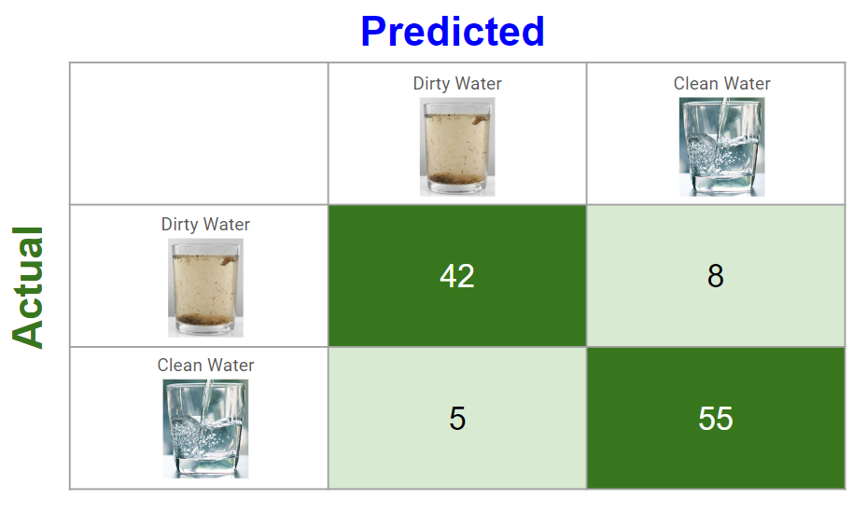

Class | Results
Dirty Water | True Positives (TP) | 42
Dirty Water | True Negatives (TN) | 55
Dirty Water | False Positives (FP) | 5
Dirty Water | False Negatives (FN) | 8
Dirty Water | True Positive Rate, Sensitivity = TP / (TP + FN) | 42 / 50 = 84%
Dirty Water | True Negative Rate, Specificity = TN / (TN + FP) | 55 / 60 = 92%
Dirty Water | False Positive Rate, Type I Error = FP / (FP + TN) | 5 / 60 = 8%
Dirty Water | False Negative Rate, Type II Error = FN / (FN + TP) | 8 / 50 = 16%
Clean Water | True Positives (TP) | 55
Clean Water | True Negatives (TN) | 42
Clean Water | False Positives (FP) | 8
Clean Water | False Negatives (FN) | 5
Clean Water | True Positive Rate, Sensitivity = TP / (TP + FN) | 55 / 60 = 92%
Clean Water | True Negative Rate, Specificity = TN / (TN + FP) | 42 / 50 = 84%
Clean Water | False Positive Rate, Type I Error = FP / (FP + TN) | 8 / 50 = 16%
Clean Water | False Negative Rate, Type II Error = FN / (FN + TP) | 5 / 60 = 8%

Step 6: Iterating and Improving Your Classifier
Based on your results from Step 6, go through at least 2 more rounds of training and testing with more data to see if you can improve the statistics. Record your results after each round.

Step 7: Prepare a Poster

