
S06.01 Worksheet: Multiclass Classifiers and Statistics
Name | .................................................................................
Class | .................................................................................

Question 1
Using the confusion matrix below, complete the table of statistics for the Sunflower and Daisy classes.
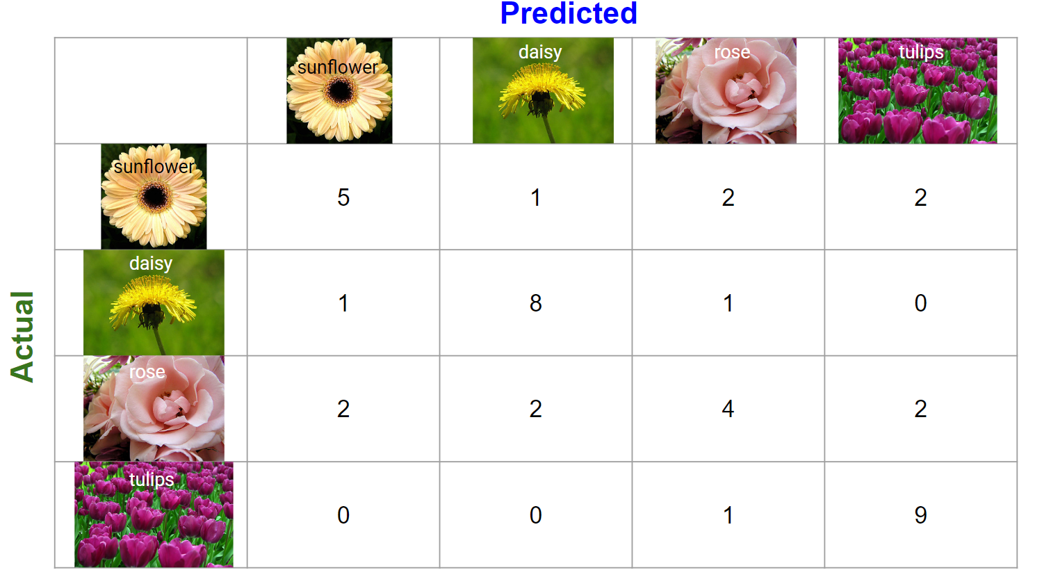

Class | Results
Sunflower | True Positives (TP)
Sunflower | True Negatives (TN)
Sunflower | False Positives (FP)
Sunflower | False Negatives (FN)
Daisy | True Positives (TP)
Daisy | True Negatives (TN)
Daisy | False Positives (FP)
Daisy | False Negatives (FN)

Question 2
Using the confusion matrix below, complete the table of statistics for each of the 3 classes in a sound classifier for baby cries.
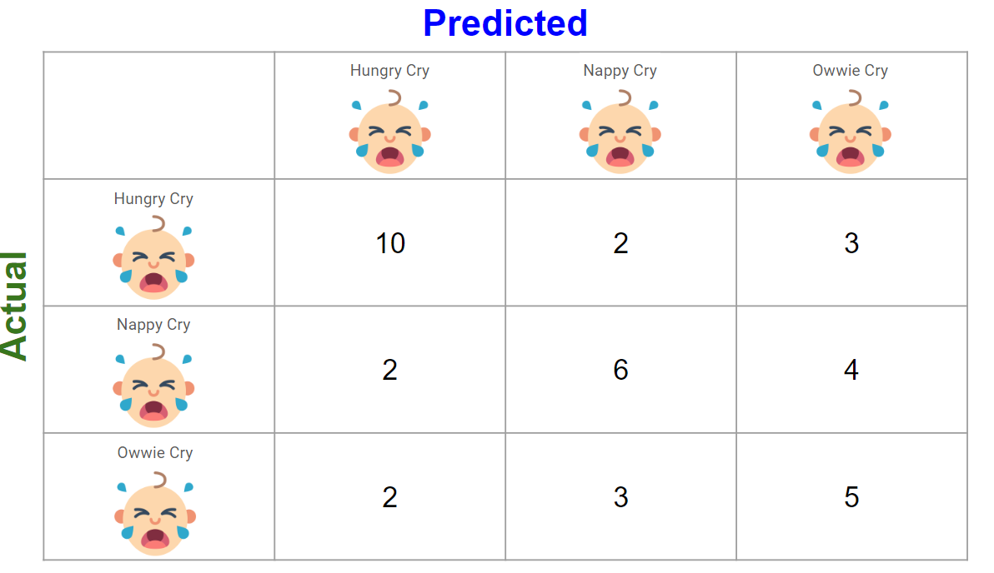
Class | Results
Hungry Cry | True Positives (TP)
Hungry Cry | True Negatives (TN)
Hungry Cry | False Positives (FP)
Hungry Cry | False Negatives (FN)
Hungry Cry | Sensitivity = True Positive Rate = TP / (TP + FN)
Hungry Cry | Specificity = True Negative Rate = TN / (TN + FP)
Hungry Cry | Type I Error = False Positive Rate = FP / (FP + TN)
Hungry Cry | Type II Error = False Negative Rate = FN / (FN + TP)
Nappy Cry | True Positives (TP)
Nappy Cry | True Negatives (TN)
Nappy Cry | False Positives (FP)
Nappy Cry | False Negatives (FN)
Nappy Cry | Sensitivity = True Positive Rate = TP / (TP + FN)
Nappy Cry | Specificity = True Negative Rate = TN / (TN + FP)
Nappy Cry | Type I Error = False Positive Rate = FP / (FP + TN)
Nappy Cry | Type II Error = False Negative Rate = FN / (FN + TP)
Class | Results
Owwie Cry | True Positives (TP)
Owwie Cry | True Negatives (TN)
Owwie Cry | False Positives (FP)
Owwie Cry | False Negatives (FN)
Owwie Cry | Sensitivity = True Positive Rate = TP / (TP + FN)
Owwie Cry | Specificity = True Negative Rate = TN / (TN + FP)
Owwie Cry | Type I Error = False Positive Rate = FP / (FP + TN)
Owwie Cry | Type II Error = False Negative Rate = FN / (FN + TP)

Do you think this classifier was accurate? Why or why not?

How do you think a classifier like this could be used in the real world?

Question 3
Build a pose classifier with three pose classes:
- Dab
- Stretch
- Step Clap

Remember to use at least 20 training samples for each class. Train the classifier with yourself and at least 1 other person.

Then test your classifier with at least 3 other people who were not involved in the training process. Each person can do 5 poses for each class, so you should have at least 15 tests for each class.

Record your confusion matrix results below.
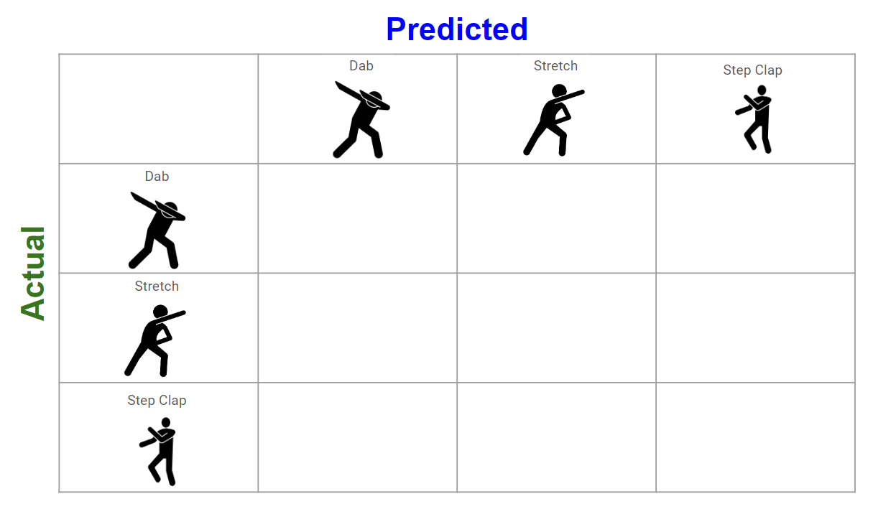

Calculate and fill in the below statistics for your classifier:

Class | Results
Dab Pose | True Positives (TP)
Dab Pose | True Negatives (TN)
Dab Pose | False Positives (FP)
Dab Pose | False Negatives (FN)
Dab Pose | Sensitivity = True Positive Rate = TP / (TP + FN)
Dab Pose | Specificity = True Negative Rate = TN / (TN + FP)
Dab Pose | Type I Error = False Positive Rate = FP / (FP + TN)
Dab Pose | Type II Error = False Negative Rate = FN / (FN + TP)
Stretch Pose | True Positives (TP)
Stretch Pose | True Negatives (TN)
Stretch Pose | False Positives (FP)
Stretch Pose | False Negatives (FN)
Stretch Pose | Sensitivity = True Positive Rate = TP / (TP + FN)
Stretch Pose | Specificity = True Negative Rate = TN / (TN + FP)
Stretch Pose | Type I Error = False Positive Rate = FP / (FP + TN)
Stretch Pose | Type II Error = False Negative Rate = FN / (FN + TP)
Step Clap Pose | True Positives (TP)
Step Clap Pose | True Negatives (TN)
Step Clap Pose | False Positives (FP)
Step Clap Pose | False Negatives (FN)
Step Clap Pose | Sensitivity = True Positive Rate = TP / (TP + FN)
Step Clap Pose | Specificity = True Negative Rate = TN / (TN + FP)
Step Clap Pose | Type I Error = False Positive Rate = FP / (FP + TN)
Step Clap Pose | Type II Error = False Negative Rate = FN / (FN + TP)

Do you think your classifier was accurate? Why or why not?

How do you think a classifier like this could be used in the real world?

