
05.01 Worksheet: Building and Evaluating Classifiers
Name | .................................................................................
Class | .................................................................................

Question 1
- What is the difference between a training dataset and a testing dataset?

- Jacki ran out of time in building her sound classifier, so just decided to use the same dataset recordings for both training and testing. What could happen as a result of doing this and explain how this might be a disadvantage for her classifier.

Question 2
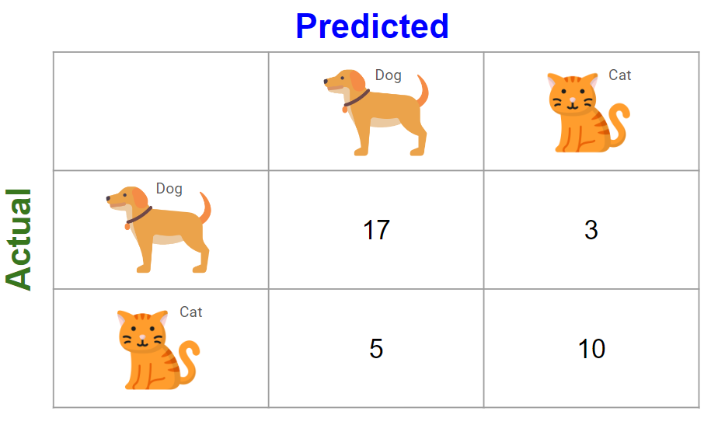
Fill in the table below:

Images of dogs which were correctly classified as dogs
Images of dogs which were incorrectly classified as cats
Images of cats which were incorrectly classified as dogs
Images of cats which were correctly classified as cats
Total images of cats
Total images of dogs

Question 3
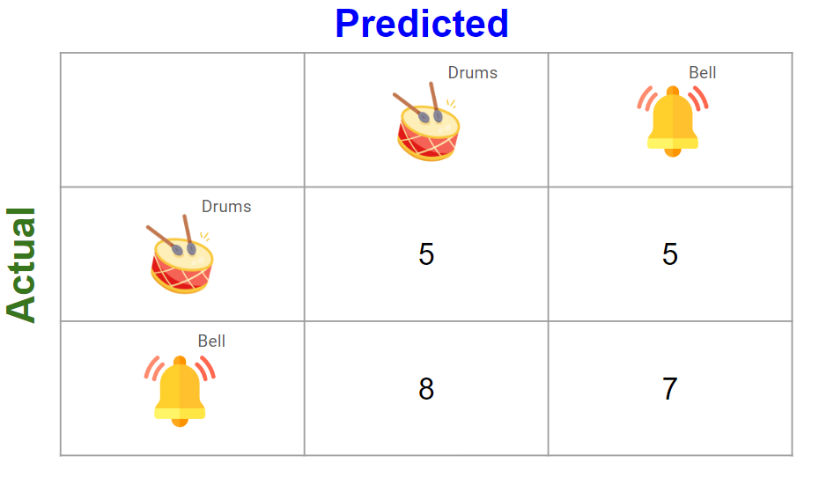

Fill in the table below:

Sounds of drums which were incorrectly classified as bells
Sounds of bells which were incorrectly classified as drums
Sounds of bells which were correctly classified as bells
Sounds of drums which were correctly classified as drums
Total sounds of bells
Total sounds of drums

Do you think this is a very accurate classifier? Why or why not?

Question 4
Your task is to build an image classifier that detects two classes of sushi:
- Tuna Nigiri
- Salmon Nigiri

In the training process, remember to use at least 20 images of each class.
In the testing process, use at least 10 images of each class which were not used in the training set.

Fill in the confusion matrix below once you have completed testing:
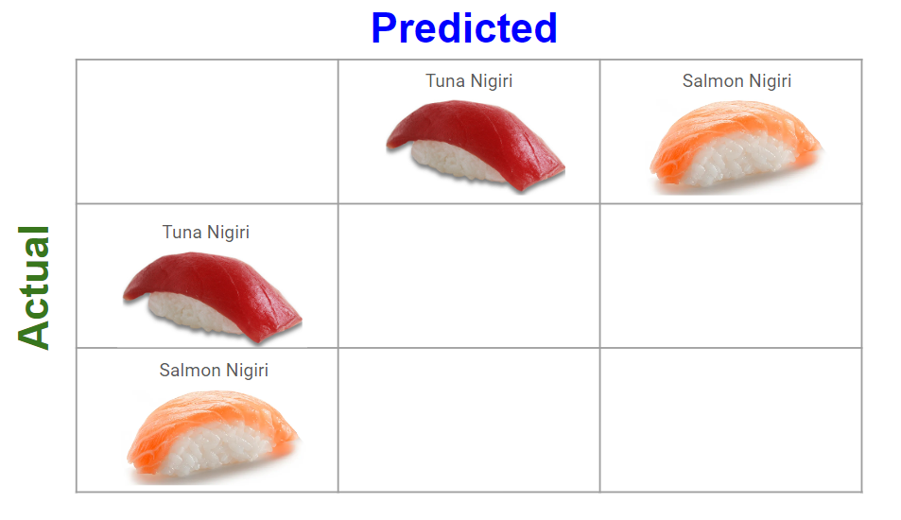
Fill in the table below:

Images of Salmon which were correctly classified as Salmon
Images of Salmon which were incorrectly classified as Tuna
Images of Tuna which were correctly classified as Tuna
Images of Tuna which were incorrectly classified as Salmon
Total Images of Salmon
Total Images of Tuna

Do you think your classifier was accurate? Why or why not?

How do you think a classifier like this could be used in the real world?

