
03.01 Worksheet: Generative AI
Name | .................................................................................
Class | .................................................................................

Question 1
Predictive text on your phone works by analyzing word pairs and using statistics to take a guess at the next word you want to type. In this worksheet, we will work through creating your very own predicted sentence!

The sentences below make up the dataset that our predictive text machine is working with:

- Lightning McQueen is not just a racing champion but also an amazing athlete bro.
- A racing champion like Lightning McQueen is the ultimate athlete, he’s the best bro.
- Bro Lightning McQueen is a great athlete and the ultimate racing champion.
- In the world of racing bro Lightning McQueen is a supreme athlete and a champion bro.
- A champion and amazing racing athlete, bro Lightning McQueen is the best.
- Bro a racing champion like Lightning McQueen has to be a great athlete.


PART 1: Identifying word pairs
Use the following table to identify word pairs and how often those words occur.

There are 6 first words that have been identified for you, and you will need to choose 3 more to complete the tables below.

The first two have been completed for you.

First word | Second word | Count
Lightning | McQueen | 6

First word | Second word | Count
McQueen | is | 5
McQueen | has | 1

First word | Second word | Count
racing | champion
racing | bro
racing | athlete

First word | Second word | Count
is

First word | Second word | Count
a

First word | Second word | Count
the

First word | Second word | Count

First word | Second word | Count

First word | Second word | Count

PART 2: Constructing your First sentence
Using the tables you have created above, create your predictive sentence below!
The table below should help you in constructing your sentence. Highlight your word choice in green, and use it as the “first word” to identify your next word choices.
1st Word | 2nd Word Choices |  | 3rd Word Choices |  | 4th Word Choices |  | 5th Word Choices |  | 6th Word Choices
1st Word | Word | Count | Word | Count | Word | Count | Word | Count | Word | Count
Lightning
Lightning | McQueen | 6 | is | 5 | not
Lightning |  |  | has | 1 | a
Lightning |  |  |  |  | the

PART 3: DIY
Choose your own first word, and try to construct another sentence! You may want to extend this table to make the sentence longer!

1st Word | 2nd Word Choices |  | 3rd Word Choices |  | 4th Word Choices |  | 5th Word Choices |  | 6th Word Choices |  | 7th Word Choices
1st Word | Word | Count | Word | Count | Word | Count | Word | Count | Word | Count | Word | Count

Question 2
Write down the 3 main improvements Generative Pre-Trained Transformers added to the basic text prediction features on phones:

Question 3

Fill in the blanks in the diagram below illustrating how Generative Image AI systems perform machine learning training:
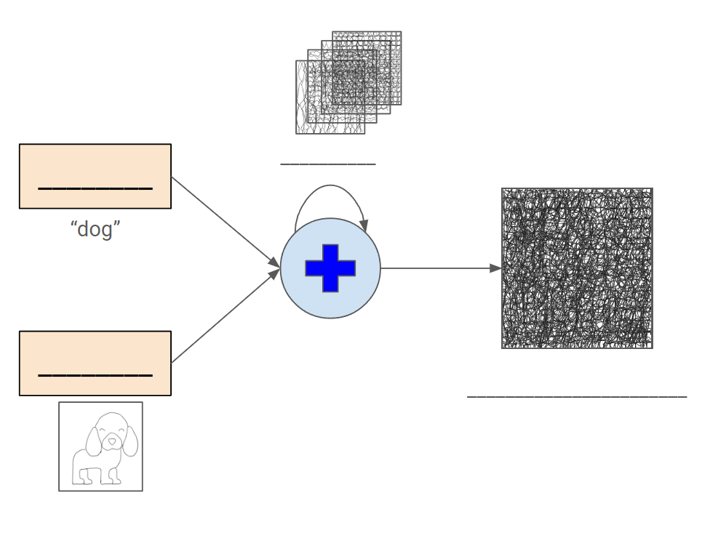

Question 4

Fill in the blanks in the diagram below illustrating how Generative Image AI systems perform image generation:

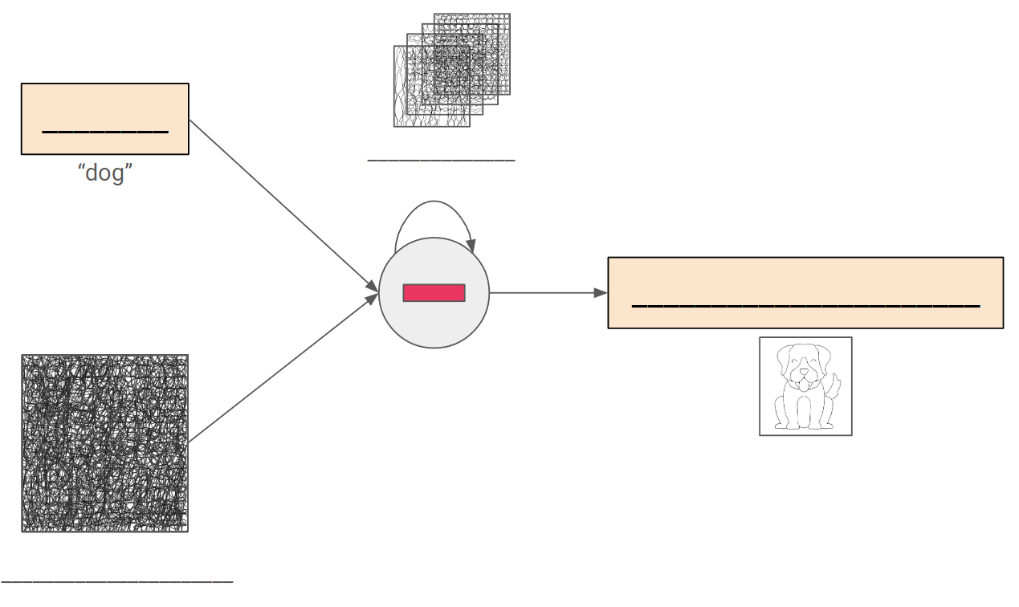

Question 5
Generative Image AI has been known to produce images of distorted human hands.



Research online to understand why this might be the case. In under 150 words explain, in your own words, the reason why Generative Image AI has trouble generating images of human hands.

