
02.01 Worksheet: Pattern-Based AI
Name | .................................................................................
Class | .................................................................................

Question 1

The diagram below refers to data which is used for an image classifier.
Fill in the boxes in the diagram with the correct words:
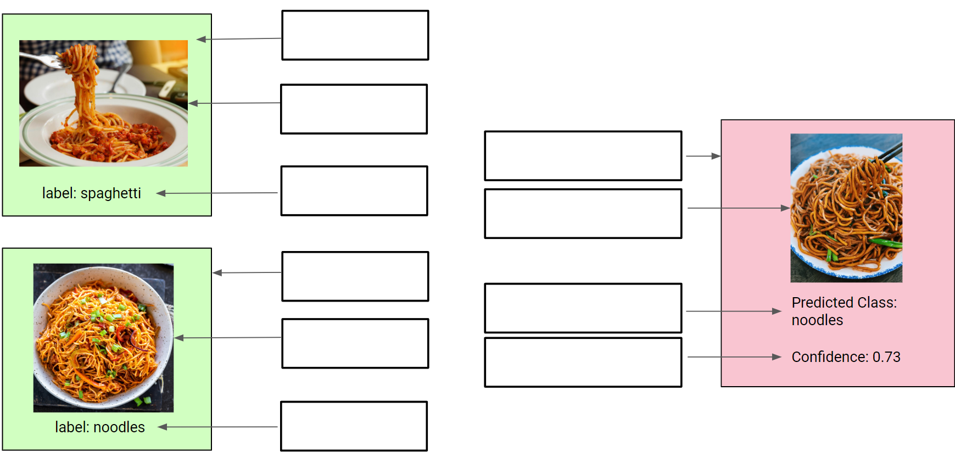

Question 2
Consider the following image classifier:
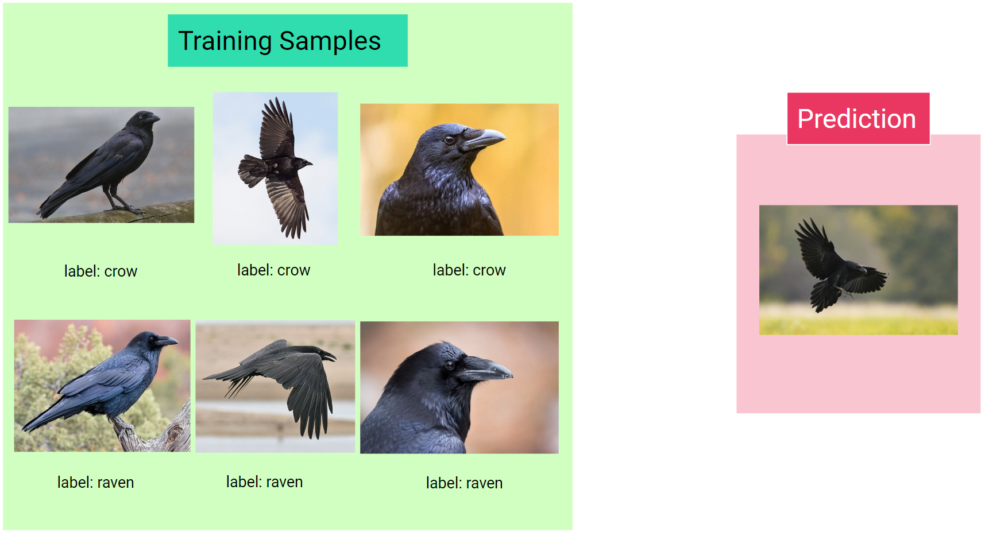
What is your prediction for the class of the image: crow or raven?

What is the confidence score for your prediction:

What were the reasons behind your choice?

Question 3
You’ve now been given the additional training samples below:
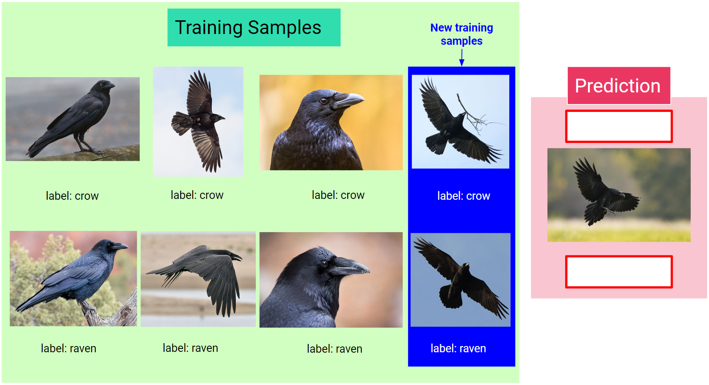

What is your prediction for the class of the image now: crow or raven? Has it changed?

What is the confidence score for your prediction now? Has it changed?

Explain why the amount and quality of training samples makes a difference to how your prediction is made and the confidence score given to your prediction.

Question 4
We’re now going to consider a sound classifier.
- The following are training samples for various classes of heart conditions. Listen to each of the samples above for each of the 3 classes

Class: Heart Murmur | Class: Extrasystole | Class: Normal
- Sample 1  - Sample 2  - Sample 3  - Sample 4 | - Sample 1  - Sample 2  - Sample 3  - Sample 4 | - Sample 1  - Sample 2  - Sample 3  - Sample 4

- Now make a prediction for each of the test sounds below, classifying them each as either: Heart Murmur, Extrasystole or Normal. Provide a confidence score for each prediction.

Test Sound | Predicted Class  (Heart Murmur, Extrasystole or Normal) | Confidence Score
Test 1
Test 2
Test 3
Test 4

How might a classifier like this be useful in the real world?

Question 5
We’re now going to build and test an image classifier using images provided for you.
The image classifier will learn and predict images belong to one of two classes:
- Lime
- Lemon

Step 1
Using Teachable Machines, build an image classifier with the 2 above classes. Make sure you use at least 20 images for each class to train the classifier. That is, you’ll need to find at least 20 images of limes and 20 images of lemons.

Watch the following videos for a walkthrough of how to use Teachable Machine to produce a classifier model for this task:
- Creating an Image Project in Teachable Machine (12:16 mins):
  - Youtube video

Step 2
Now test your classifier with the following images of limes and lemons.
Complete the table below with your test results:

Class | Total Number of Test Images | Number of Correct Predictions | Number of Incorrect Predictions
Lime
Lemon

Step 3
We’re now going to add a 3rd class to our classifier: Orange
Find at least 20 images of oranges and add them to a new class in your classifier.

Watch the following videos for a walkthrough of how to use Teachable Machine for this task:
- Adding a 3rd class to your classifier (4:37 mins):
  - Youtube video

Step 4
Now test your classifier with the following images of oranges.
Additionally, re-test your classifier with the same images of limes and lemons from before.
Complete the table below with your test results:

Class | Total Number of Test Images | Number of Correct Predictions | Number of Incorrect Predictions
Orange
Lime
Lemon

Watch the following videos for a walkthrough of how to use Teachable Machine for this task:
- Generating a URL for your classifier (1:28 mins):
  - Youtube video

Enter the URL of your completed classifier below:

Has adding the new class of oranges affected the accuracy of your classifier for lime and lemons from step 2?

Why do you think adding another class might affect the accuracy of predicting previous classes?

How might a classifier like this be useful in the real world?

Bonus Activity

Using Teachable Machines, create your own image classifiers!

